

PON Deployment Lab

E874, Revision-B

SAOS 10.7.0

Hands-on Training Lab Guide

**LEGAL NOTICES**

THIS DOCUMENT CONTAINS CONFIDENTIAL AND TRADE SECRET INFORMATION OF CIENA CORPORATION AND ITS RECEIPT OR POSSESSION DOES NOT CONVEY ANY RIGHTS TO REPRODUCE OR DISCLOSE ITS CONTENTS, OR TO MANUFACTURE, USE, OR SELL ANYTHING THAT IT MAY DESCRIBE. REPRODUCTION, DISCLOSURE, OR USE IN WHOLE OR IN PART WITHOUT THE SPECIFIC WRITTEN AUTHORIZATION OF CIENA CORPORATION IS STRICTLY FORBIDDEN.

EVERY EFFORT HAS BEEN MADE TO ENSURE THAT THE INFORMATION IN THIS DOCUMENT IS COMPLETE AND ACCURATE AT THE TIME OF PUBLISHING; HOWEVER, THE INFORMATION CONTAINED IN THIS DOCUMENT IS SUBJECT TO CHANGE.

While the information in this document is believed to be accurate and reliable, except as otherwise expressly agreed to in writing CIENA PROVIDES THIS DOCUMENT “AS IS” WITHOUT WARRANTY OR CONDITION OF ANY KIND, EITHER EXPRESS OR IMPLIED. The information and/or products described in this document are subject to change without notice. For the most up-to-date technical publications, visit [www.ciena.com](http://www.ciena.com).s

**Copyright© 2015-2021 Ciena® Corporation – All Rights Reserved**

The material contained in this document is also protected by copyright laws of the United States of America and other countries. It may not be reproduced or distributed in any form by any means, altered in any fashion, or stored in a database or retrieval system, without the express written permission of Ciena Corporation.

**Security**

Ciena cannot be responsible for unauthorized use of equipment and will not make allowance or credit for unauthorized use or access.

**Contacting Ciena**

|  |  |  |
| --- | --- | --- |
| Corporate headquarters | 410-694-5700 or 800-921-1144 | www.ciena.com |
| Customer technical support/warranty | |  |
| In North America | 1-800-CIENA24 (243-6224)  410-865-4961 | Email: CIENA24@ciena.com |
| In Europe, Middle East, and Africa | 800-CIENA-24-7 (800-2436-2247)  +44-207-012-5508 | Email: CIENA24@ciena.com |
| In Asia-Pacific | 800-CIENA-24-7 (800-2436-2247)  +81-3-6367-3989  +91-124-4340-600 | Email: CIENA24@ciena.com |
| In Caribbean and Latin America | 800-CIENA-24-7 (800-2436-2247)  410-865-4944 (USA) | Email: CIENA24@ciena.com |
| Sales and General Information | 410-694-5700 | E-mail: sales@ciena.com |
| In North America | 410-694-5700 or 800-207-3714 | E-mail: sales@ciena.com |
| In Europe | +44-207-012-5500 (UK) | E-mail: sales@ciena.com |
| In Asia | +81-3-3248-4680 (Japan) | E-mail: sales@ciena.com |
| In India | +91-124-434-0500 | E-mail: sales@ciena.com |
| In Latin America | 011-5255-1719-0220 (Mexico City) | E-mail: sales@ciena.com |
| Training |  | E-mail: learning@ciena.com |

For additional office locations and phone numbers, please visit the Ciena website at [www.ciena.com](http://www.ciena.com)

Change History

|  |  |  |
| --- | --- | --- |
| Revision | Publication  Date | Reason for Change |
| A | 01/2021 | Initial release, updated to SAOS 10.5.1 |
| B | 11/2021 | Updated to SAOS 10.7.0 |



Contents

Lab 1: Lab Topology Overview 5

Lab 2: Set up the PON OLT management domain 9

Lab 3: OLT Configuration 15

Lab 4: Verify OLT Firmware 23

Lab 5: ONU Configuration 25

Lab 6: ONU UNI Port Configuration 31

Lab 7: PON Connection Configuration 35

Lab 8: PON Operations Tasks 51

Lab 9 : Events and Alarms 58

Appendix: PON Firmware Updates: 61

## Lab 1: Lab Topology Overview

### Objectives

* Discuss the physical connection between the nodes
* Identify the physical ports used to connect the nodes
* Identify the IP addressing scheme to be used in this course
* Check the SAOS 10 lab environment

### Task 1: Revisit Basic XGS-PON Concepts

1. Your instructor will explain the concept of OLT, ONT, attenuation, splitter, UPC vs APC and optical budget.

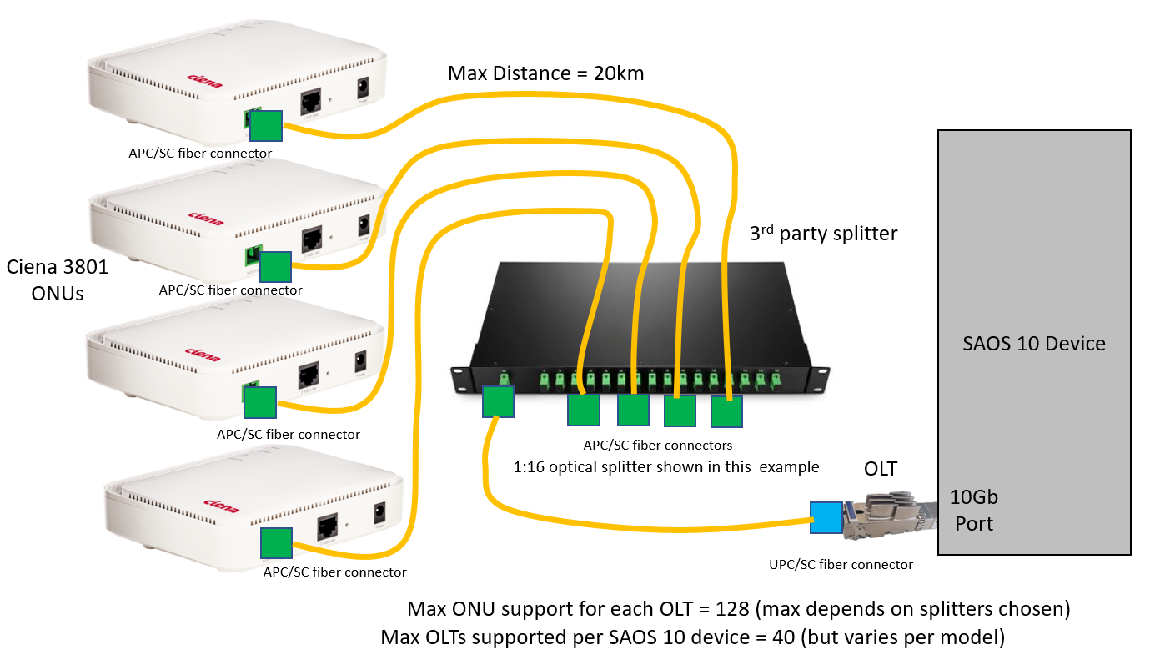

1. Your instructor will explain the different elements of the Ciena XGS-PON solution, including the symbiotic relationship between the SAOS 10 Device and the pluggable XGS-PON OLT.
2. As of SAOS 10.7.0 XGS-PON pluggable OLTs are supported on 3924,3926,3928, 5130,5131, 5132, 5144, 5162, 5164, 5166, 5168, 5170 and 5171 SAOS 10 supporting devices. You will also get a short overview of the two Ciena ONUs, 3801 and 3802.

### Task 2: Revisit SAOS 10 L3 Interfaces Concepts

1. Your instructor will explain the concepts, ETTP, Logical Port, Flow Point, Classifiers, and Forwarding domains. These will be required to set up the PON management domain.

### Task 3: Gather Lab Information

1. Your instructor will divide the class into two or four teams. Write down the information provided by the instructor:
2. I am in Team: _______________________________________________________________
3. SAOS 10 Device Login Credentials:
   1. Management IP Address: _______________________________________________
   2. CLI Username: _______________________________________________________
   3. Password: ___________________________________________________________

**NOTE:** This course is developed using the Hanover lab, see lab guide below.

* We will use two pluggable OLTs, in ports 19 and 20 of the SAOS 10 device, in all the lab exercises.
* All labs are done using CLI commands or WebGUI on the SAOS 10 chassis, which runs SAOS 10.7.0
* Multiple ONUs cannot be directly connected to the OLTs, without a passive optical splitter. The use of an optical splitter allows a single OLT to support up to 128 ONUs. This number will be limited based on the optical splitter chosen.
* Using an optical splitter will attenuate the optical signal level. Depending on the split ratio of the optical splitter an additional attenuator may be required so that the receiving signal is within the acceptable range. Not having sufficient attenuation will damage the optical equipment (both on ONU and OLT side).
* Our lab does not have optical splitters. In our lab we compensate for the passive splitter induced optical loss by using a 20dB or 25dB UPC attenuator on each OLT.

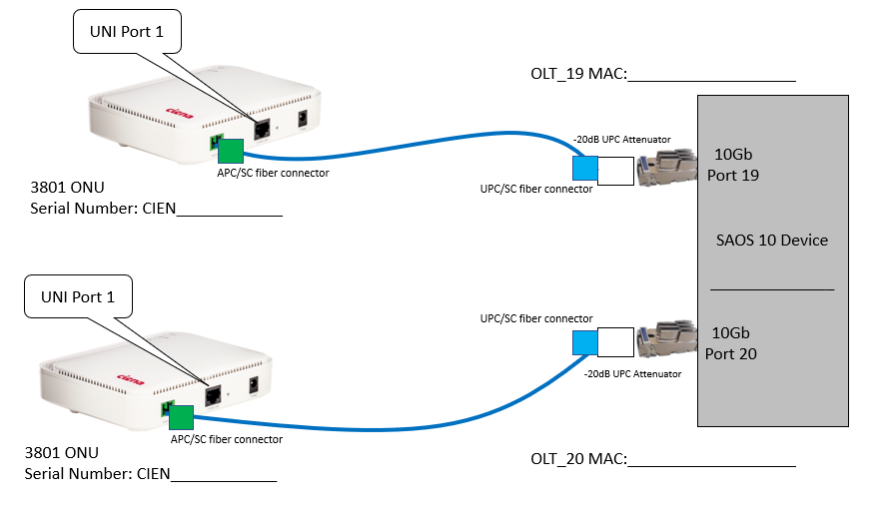

### Task 4: Log in to the Nodes

1. Use Putty/SecureCRT to log in to the nodes using the username/password provided by the instructor.

-End of lab 1

## Lab 2: Set up the PON Management Domain

### Objectives

* Configure a classifier for management
* Configure the forwarding-domain for management
* Configure the management flow-points for both OLTs
* Verify Forwarding Domain and Flow-points
* Configure the management IP interface
* Verify the operational status of the interface
* Configure the OLTs
* Verify the operational status of the OLTs

Both OLTs will use the same management interface and for that we need classifiers and a common forwarding domain, with two flow-points attached to it.

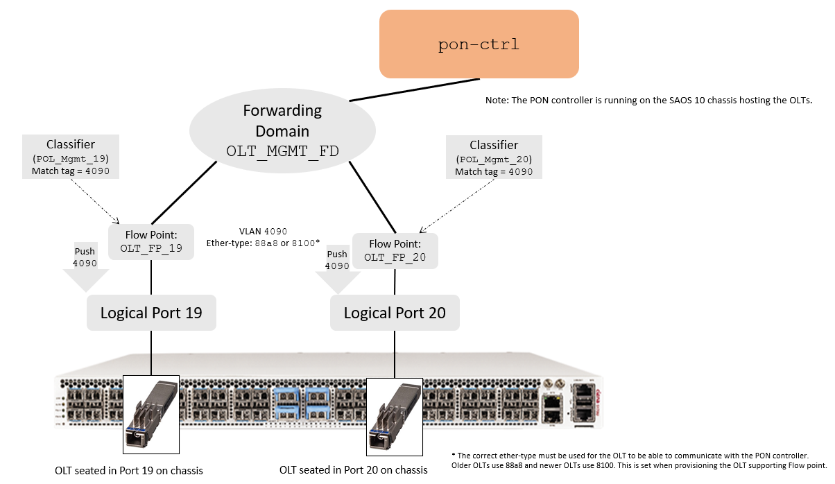

### Task 1: Configure a Classifier for Management

1. On the 5170-2, as per the OLT assigned to your team, execute the following commands:
   1. OLT_19:
2. 5170-2> **config**
3. diag@5170-2# **classifiers classifier POL_Mgmt_19 filter-entry vtag-stack vtags 1 vlan-id 4090**
   1. OLT_20:
4. 5170-2> **config**
5. diag@5170-2# **classifiers classifier POL_Mgmt_20 filter-entry vtag-stack vtags 1 vlan-id 4090**

### Task 2: Configure Common Forwarding-domain for Management

1. On the 5170-2, execute the following command (just once, to be used by both teams):
2. 5170-2> **config**
3. diag@5170-2# **fds fd OLT_MGMT_FD mode vpls**

### Task 3: Configure Flow-points for Management

1. On the 5170-2, as per the OLT assigned to your team, execute the following commands to:

* Create the management flow-point on the logical port where the OLT resides
* Modify the management flow-point on the logical port where the OLT resides

**Note:** We set OLT management traffic with the highest priority (7) to ensure the OLT is always manageable in the case of traffic congestion.

a. OLT_19:

1. 5170-2> **config**
2. diag@5170-2# **fps fp OLT_FP_19 fd-name OLT_MGMT_FD logical-port 19 stats-collection on classifier-list POL_Mgmt_19**
3. diag@5170-2# **fps fp OLT_FP_19 fd-name OLT_MGMT_FD logical-port 19 mac-learning enabled egress-l2-transform push-vid-4090 vlan-stack 1 push-vid 4090 push-tpid tpid-88a8 push-pcp pcp-7**

b. OLT_20:

1. 5170-2> **config**
2. diag@5170-2# **fps fp OLT_FP_20 fd-name OLT_MGMT_FD logical-port 20 stats-collection on classifier-list POL_Mgmt_20**
3. diag@5170-2# **fps fp OLT_FP_20 fd-name OLT_MGMT_FD logical-port 20 mac-learning enabled egress-l2-transform push-vid-4090 vlan-stack 1 push-vid 4090 push-tpid tpid-88a8 push-pcp pcp-7**

### Important Note: Older Ciena OLTs use the ether-type of 88a8, while newer OLTs use an ether-type of 8100. If your OLT does not go into an operationally “Active” state or gets stuck in the “configured” state, try changing the ether-type values in the commands above. As of 10.7.0 it is possible to set OLT management using untagged frames. See 10.7.0 PON OAM User Guide for details.

### Task 4: Verify Forwarding Domain and Flow-points

### Verify the classifiers you created:

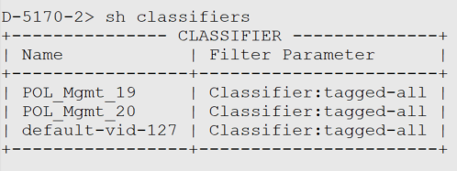

### Verify whether the Forwarding Domain was created correctly:

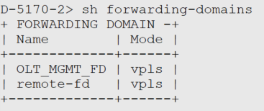

### Verify the operational state of the flow-points you just created.

### 

### Task 5: Configure Common Management IP Interface

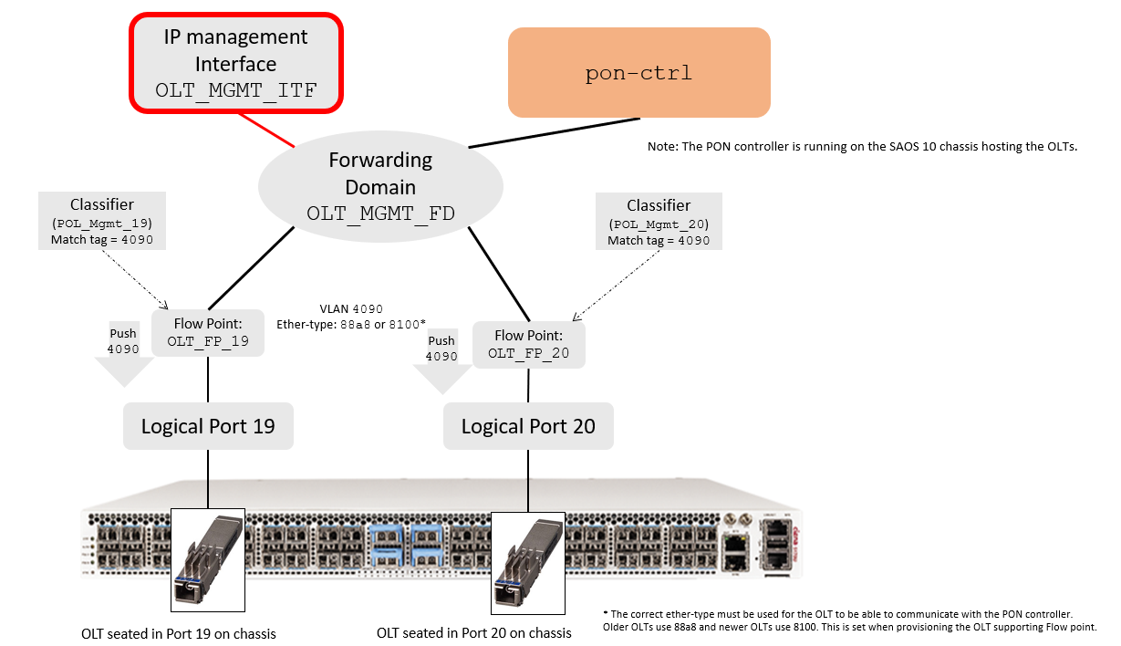

1. On the 5170-2, execute the following commands (just once, to be used by both teams):
2. 5170-2> **config**
3. diag@5170-2# **oc-if:interfaces interface OLT_MGMT_ITF config name OLT_MGMT_ITF cn-if:type ip mtu 1500 admin-status true underlay-binding config fd OLT_MGMT_FD**

### Task 6: Verify the Management IP Interface

1. Verify the existing IP interfaces with this command:

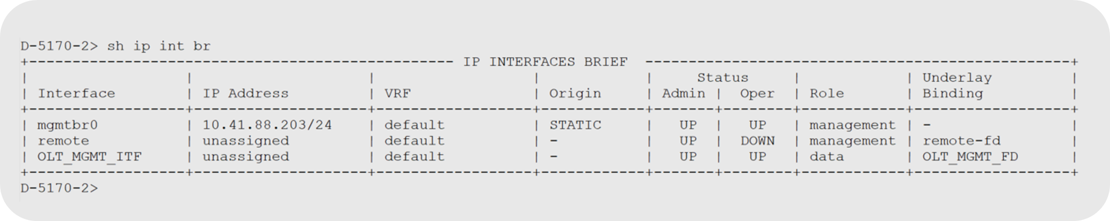

1. For your PON Management interface, verify the administrative and operational states.

If the output is different from the one shown here, talk to your instructor.

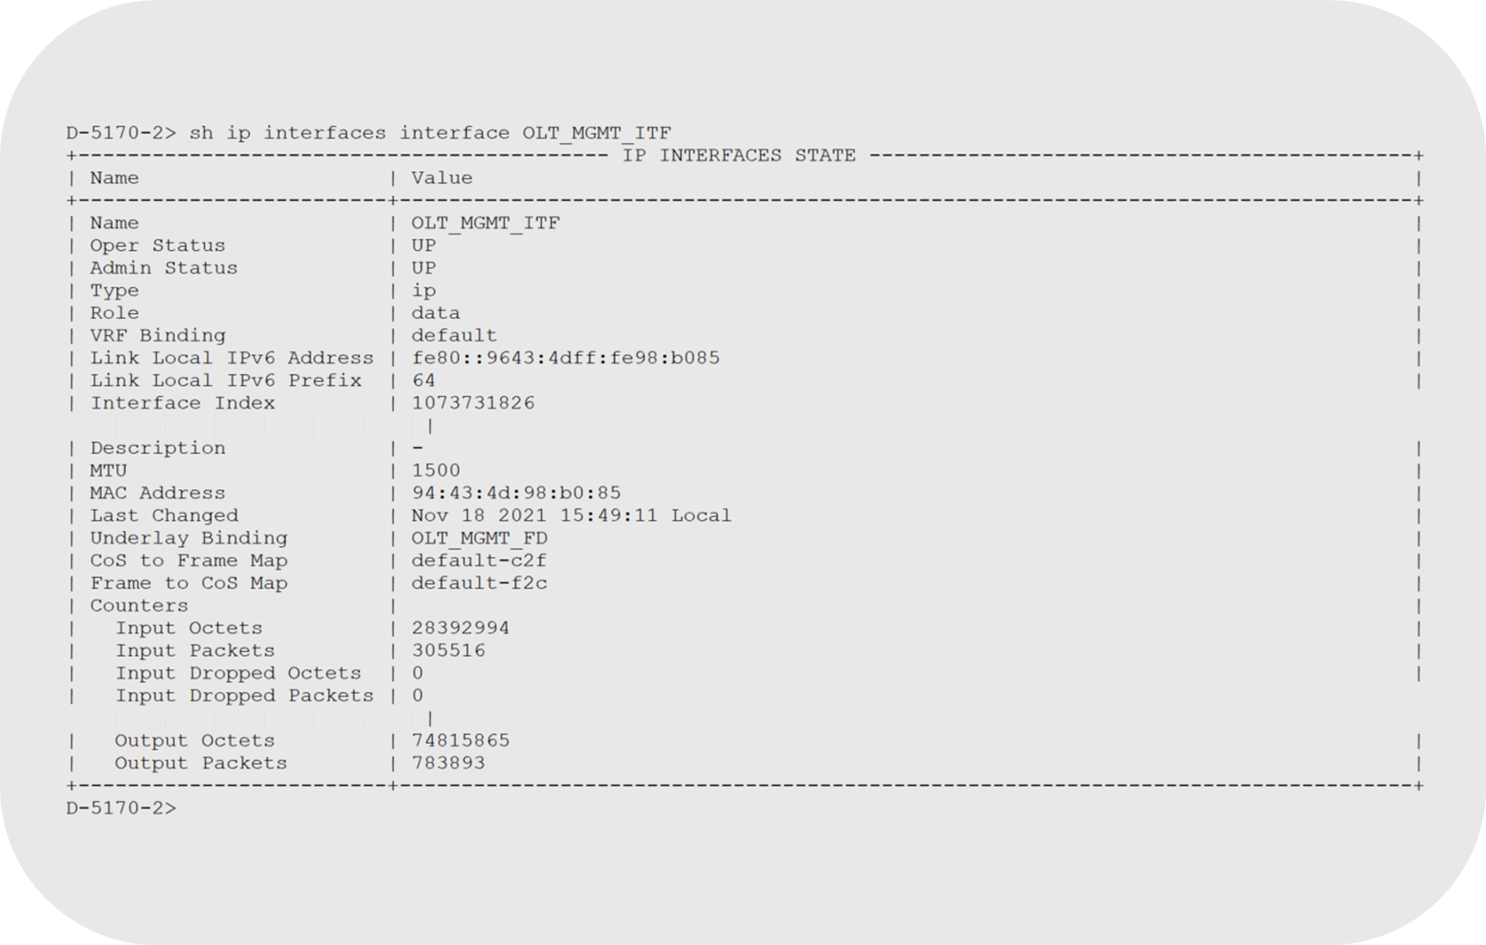

-End of Lab 2

## Lab 3: OLT Configuration

### Objectives

* Review the steps required for PON deployment
* Gather required information required to deploy OLT in PON Controller
* Document the required information required to deploy OLT in PON Controller
* Configure the OLTs
* Verify the OLT status

### Task 1: Review steps required to configure PON

1. Understand the steps required to configure a working XGS-PON service, your instructor will go over these steps with you.

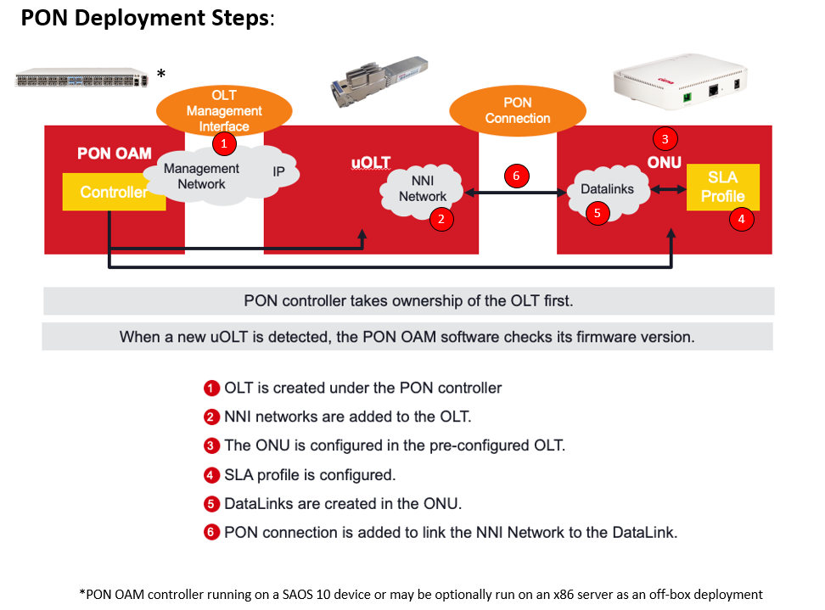

Note: SLA Profiles are actually built and stored in the OLTs. They are shown here in this diagram on the ONU to illustrate that they are applied to ONUs and dictate the service level a given ONU is capable of providing.

### Task 2: Gather required information required to deploy OLT in PON Controller

1. Using the appropriate ‘show’ command, verify the details of the OLTs in both port 19 and 20. The example below shows the command and results for transceiver in port 20. The OLT MAC is in the vendor serial number field. In this example, the OLT inserted in port 20 has a MAC address of E8:B4:70:70:05:86.

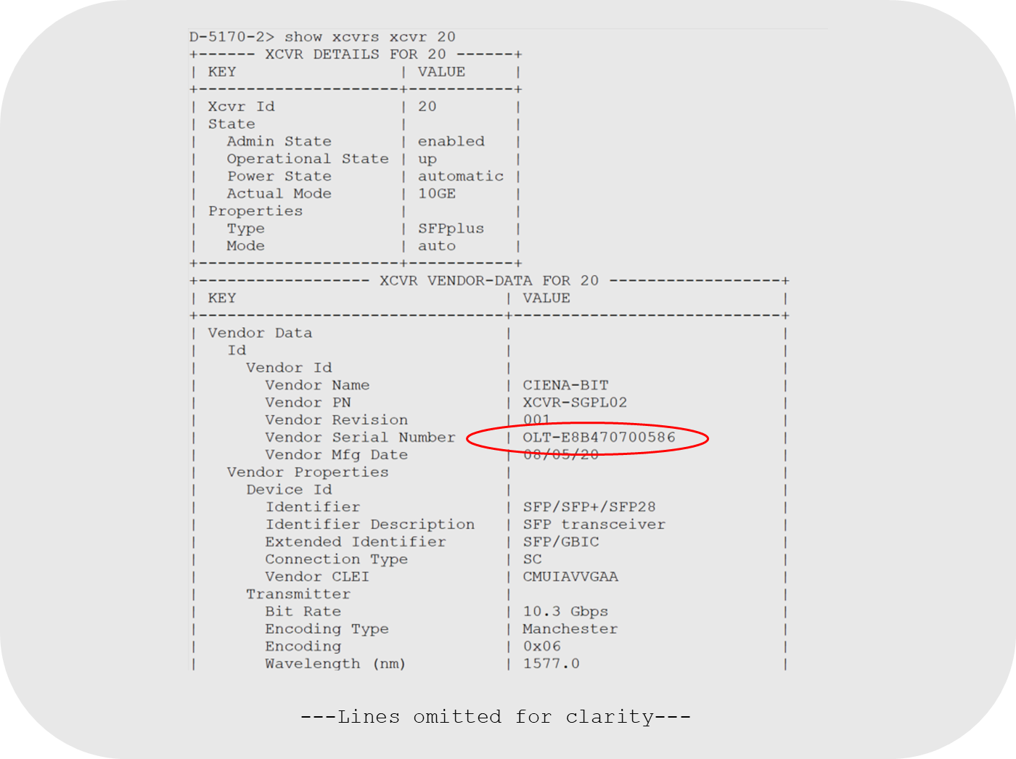

### Task 3: Document the required information required to deploy OLT in PON Controller

Write down the MAC addresses for the OLT you are about to configure, using the vendor serial number shown in Task 1, you will need this information to define the OLT in the PON controller:

1. OLT_19:

MAC address: ______________________________________________

1. OLT_20:

MAC address: ______________________________________________

### Task 4: Configuring the OLTs

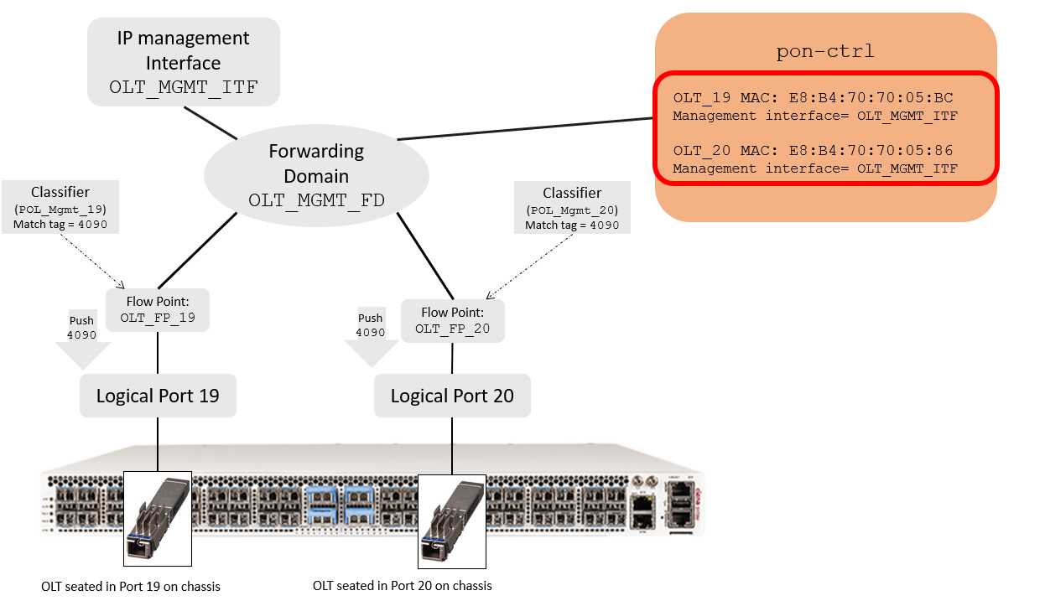

Execute the following OLT configuration commands on the assigned SAOS 10 device, against your assigned OLT. Be sure to provision the corresponding correct OLT MAC address for your Team’s OLT. Provision only your assigned OLT.

1. OLT_19:
2. D-5170-2> **config**
3. diag@D-5170-2#**pon-ctrl olts olt OLT_19 admin-state enabled mac-address E8:B4:70:70:05:BC management-interface OLT_MGMT_ITF pon-mode xgs-pon auto-boot-mode disabled upstream-fec-0 enabled upstream-preamble-0 64 downstream-fec enabled encryption-mode disabled guard-time 16 max-nni-frame-size 9600 max-pon-frame-size 9600** **auto-assigned-ids enabled auto-onu-upgrade disabled**
4. OLT_20:
5. D-5170-2> **config**
6. diag@D-5170-2# **pon-ctrl olts olt OLT_20 admin-state enabled mac-address E8:B4:70:70:05:86 management-interface OLT_MGMT_ITF pon-mode xgs-pon auto-boot-mode disabled upstream-fec-0 enabled upstream-preamble-0 64 downstream-fec enabled encryption-mode disabled guard-time 16 max-nni-frame-size 9600 max-pon-frame-size 9600 auto-assigned-ids enabled auto-onu-upgrade disabled**

OLT Provisioning parameters description:

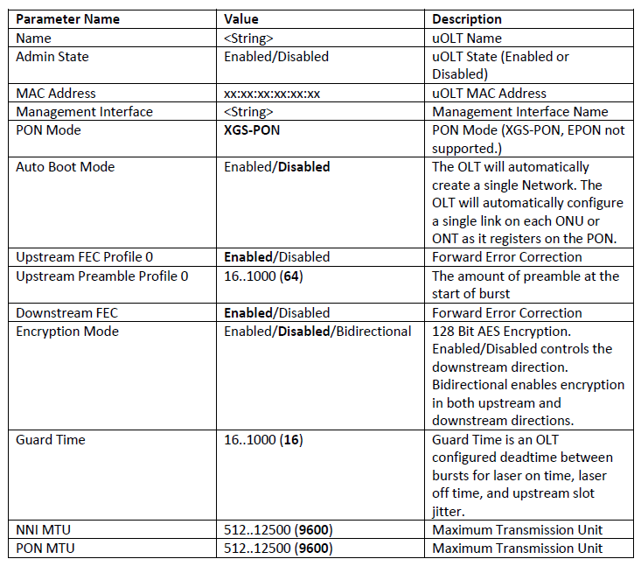

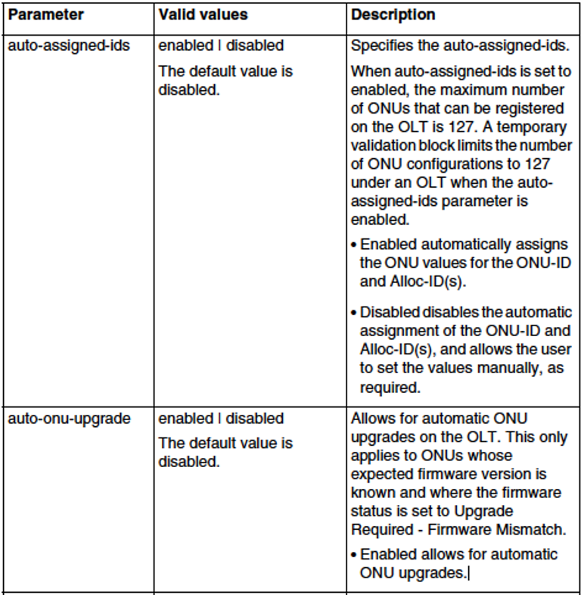

### Task 5: Verify OLT Status

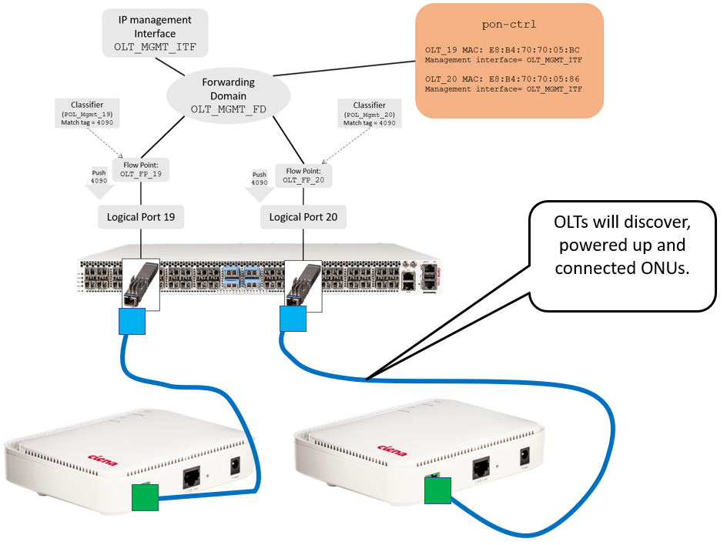

1. Verify all configured OLTs on the host platform, using the following ‘show’ command:

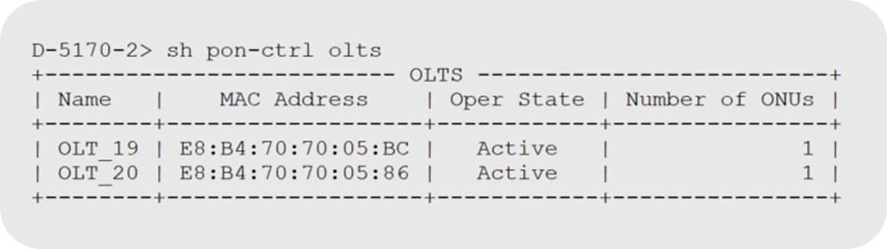

* The number of ONUs will be more than zero if any ONUs are already physically connected to the OLT. In our lab, the optical connections between OLT and ONUs are already made.
* **If the operational status is anything other than “active” consult with your instructor.**

**Note on optical connections between ONUs and OLTs**:

ONUs should never be directly connected to OLTs without the proper optical attenuation. Doing so, can cause optical receive levels exceeding the limits recommended on the OLT and/or ONUs. This could cause equipment damage. A passive optical splitter with sufficient split ratio along with the use of optical attenuators can provide the required reduction in optical levels between ONU and OLT. In our lab setup, optical attenuators are used to simulate the splitter loss and ensure proper optical levels are maintained between OLT and ONUs.

This table shows the effects of different optical split ratio and the required attenuation needed when using optical splitters.

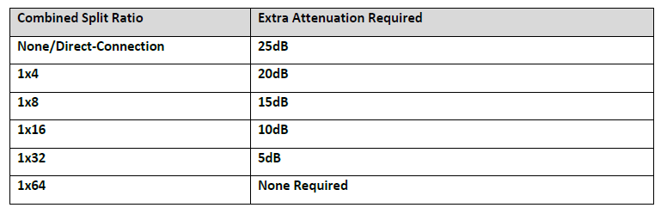

Example of a 1:16 optical splitter used in a simulated PON deployment:



2. Verify the details of the specific OLT (example shown for OLT_19):

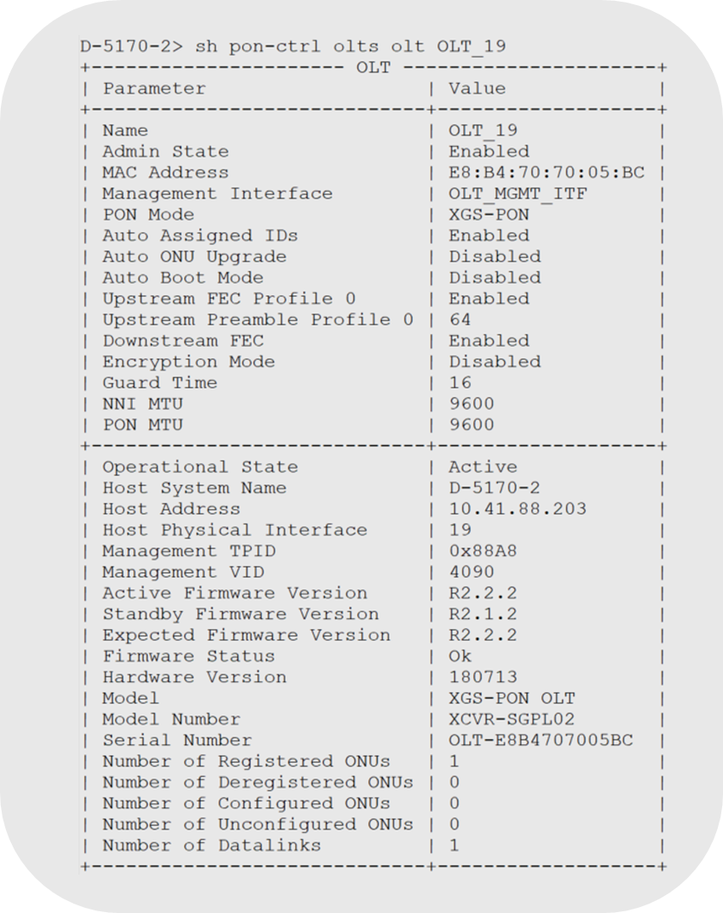

Note:

The OLT firmware status should be “**OK**”. If it is an “unknown” state, then it usually indicates a problem with the OLT to PON controller communication. Additionally, If your OLTs stay in a “**configured**” state and does not go into an “**active**” operational state as shown above, change the ether-type value on the PON management flow point as explained in Lab 2 of this lab guide.

3. Verify the OLT host information:

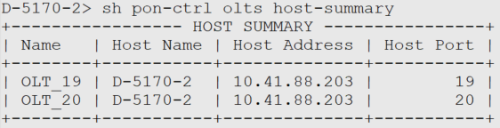

-End of lab 3

## Lab 4: Verify OLT Firmware

**Objectives**

Verify the OLT firmware

**Task 1: Verify the OLT firmware**

The OLT firmware is dependent on the underlying SAOS 10 SW release running on the SAOS 10 device where the OLT is installed. The PON solution REQUIRES the hosting SAOS 10 devices’ SW image and OLT firmware image correspond. For each SAOS 10 SW release, there is an expected OLT Firmware version. The table below lists the SAOS 10 release and its expected OLT firmware version.

IMPORTANT NOTE: The OLT firmware is included part of the SAOS 10 SW load running on the SAOS 10 Device that hosts the OLT. You **DO NOT** have to load additional SW to upgrade OLT firmware.

Anytime a new OLT is added, the SAOS 10 device will check the firmware on the OLT and compare it to what version it is expected to run. If it is different, then an upgrade or downgrade will be required on the new OLT to ensure it matches what the hosting SAOS 10 device expects.

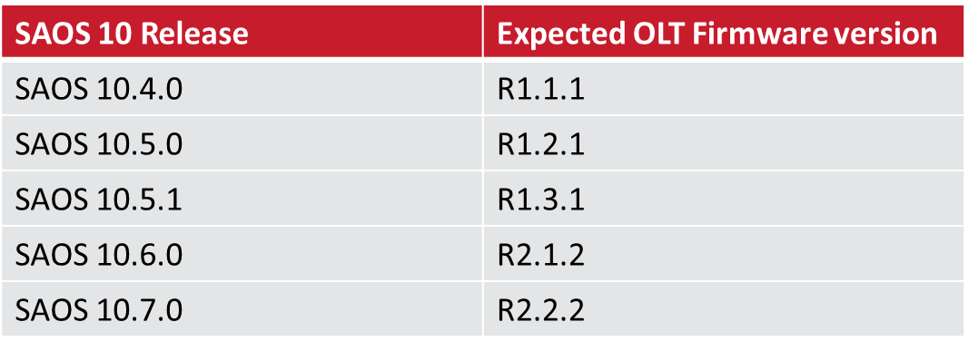

There are two OLT firmware update behaviors depending on SAOS 10 Release:

* **From SAOS 10 Release 10.6.0 and newer**. All new or replacement OLTs **will automatically be upgraded or downgraded** to match the expected firmware version of the current SAOS 10 release running on the host SAOS 10 device.
* **Earlier SAOS 10 Releases up to SAOS 10.5.1**. The OLT will detect the newer version, but **manual install and activation commands are required** to be issued for any new or replacement OLTs seated into host SAOS 10 device.

Verify your OLT firmware using the following show command against your teams assigned OLT. OLT_19 is shown here as an example.



Note that this OLT operationally “Active” and is using OLT firmware version R2.1.1 and that the firmware status is “OK”

-End of Lab 4

## Lab 5: ONU Configuration

### Objectives

* Verify the connected ONUs before the configuration
* Configure the ONUs connected the OLTs
* Verify the status of the configured ONUs
* Verify the diagnostic data for the configured ONUs

### Task 1: Verify the Connected ONUs before Configuration

1. Verify that one ONU is already physically connected to each of the OLTs:



1. Verify that those ONUs currently have an operational state of ‘Unconfigured’:

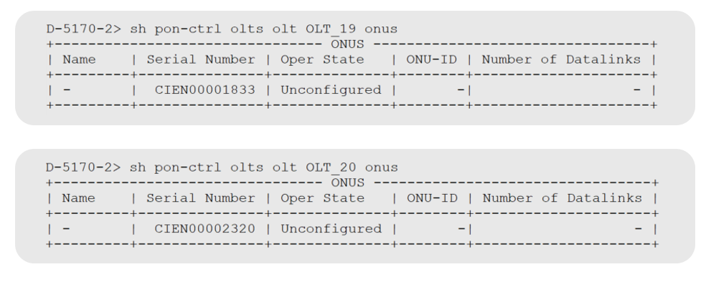

Note: the serial numbers may vary depending on the lab used for this exercise. Be sure to use the serial number from this show command on your lab equipment.

### Task 2: Configure Connected ONUs

1. Issue **the show pon-ctrl olts OLT_xx** **onus** command against your assigned OLT port to get the serial number of the ONU connected to your port:

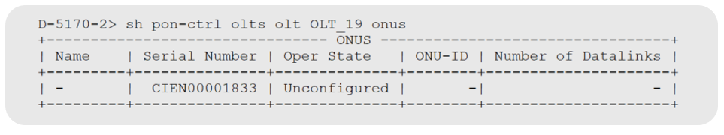

1. Make sure to use the serial number of the ONU that is connected to your assigned OLT. Register the ONU against its attached OLT in the PON controller by issuing the following command:

Do this for your Teams assigned OLT/ONUs only.

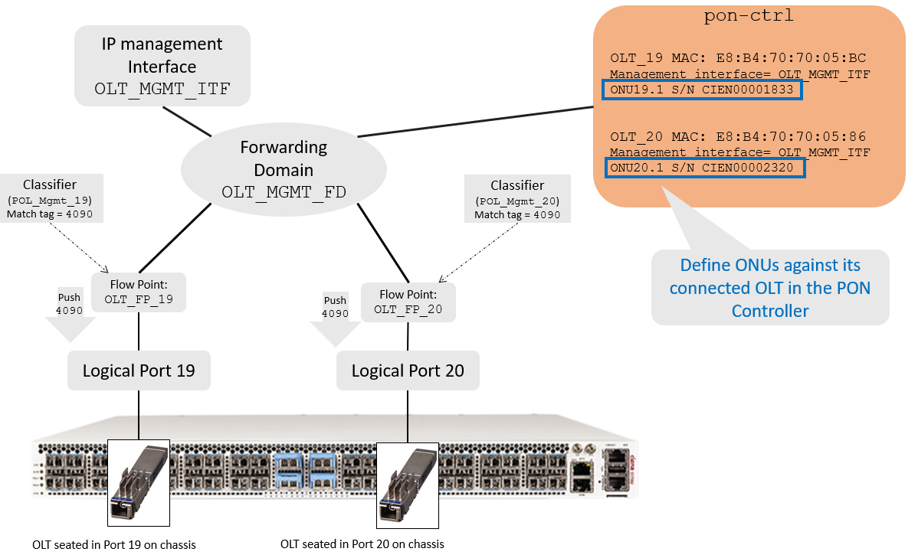

* 1. OLT_19:

1. 5170-2> config
2. diag@5170-2# **pon-ctrl onus onu ONU19.1 OLT_19 serial-number CIEN0000XXXX**
   1. OLT_20
3. 5170-2> **config**
4. diag@5170-2# **pon-ctrl onus onu ONU20.1 OLT_20 serial-number CIEN0000XXXX**

### Task 3: Verify the Status of the Configured ONUs

1. Verify ONU registration status with these commands:

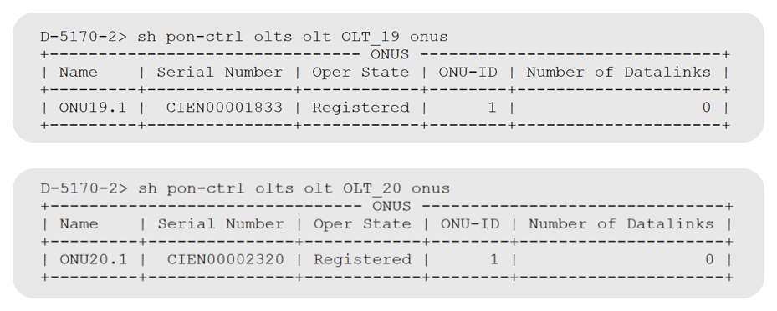

1. Verify the detailed ONU information with these commands:

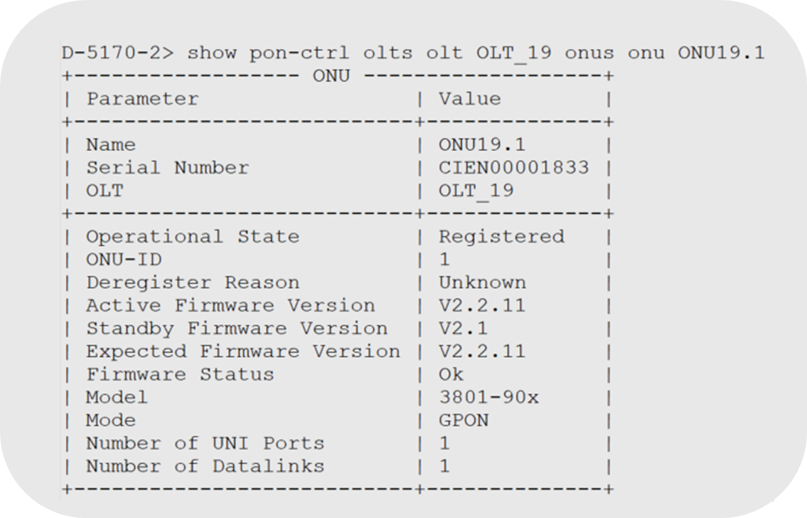

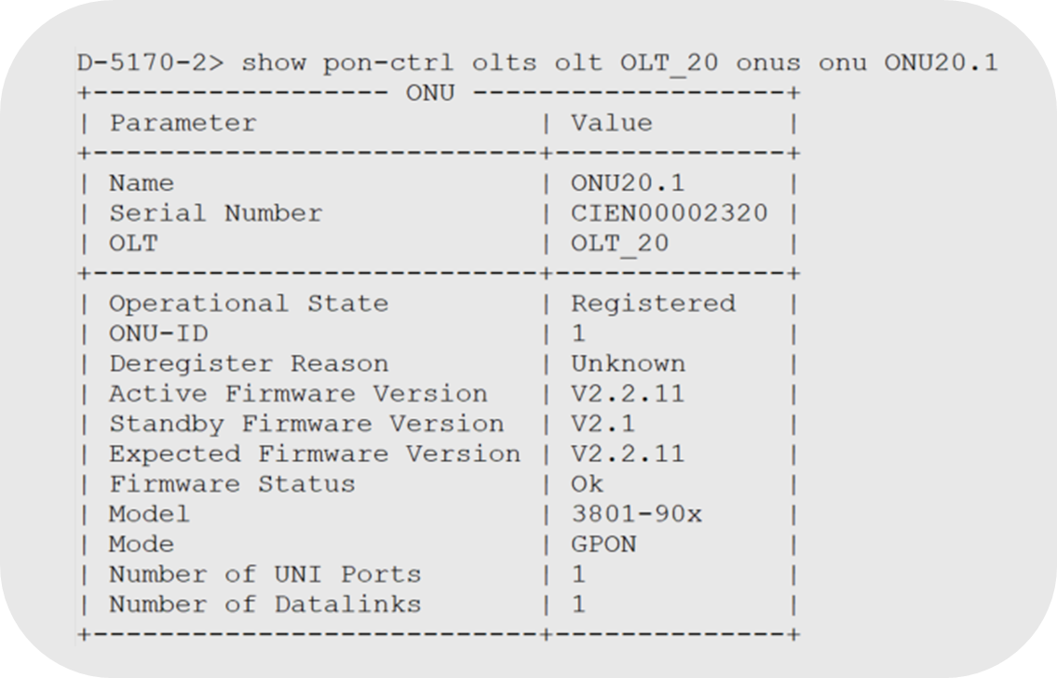

1. Verify the ONU summary information for all OLTs with this command:

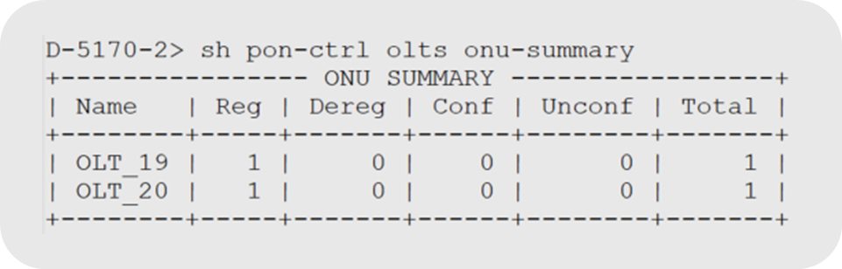

### Task 4: Verify the Diagnostic Data for the Connected ONUs

Verify the diagnostic data of the ONUs, using the following command.

The ONU diagnostic data contains the following items:

* OLT Rx power (dBm)
* OLT Tx power (dBm)
* ONU Rx power (dBM)
* ONU Tx power (dBm)
* Laser bias current (mA)
* Power feed voltage (V)
* Temperature (Celsius)

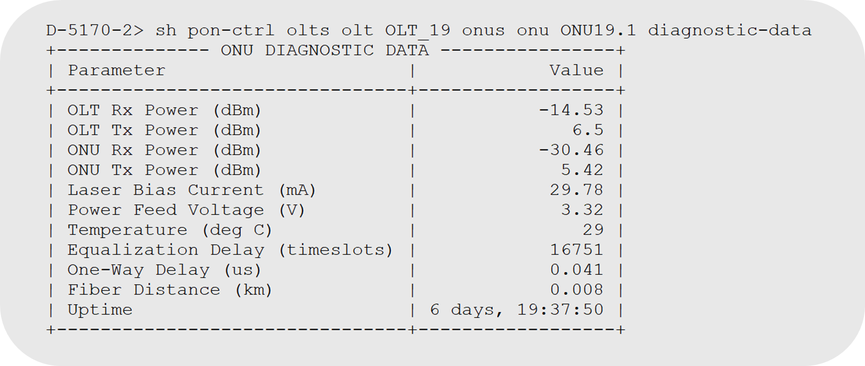

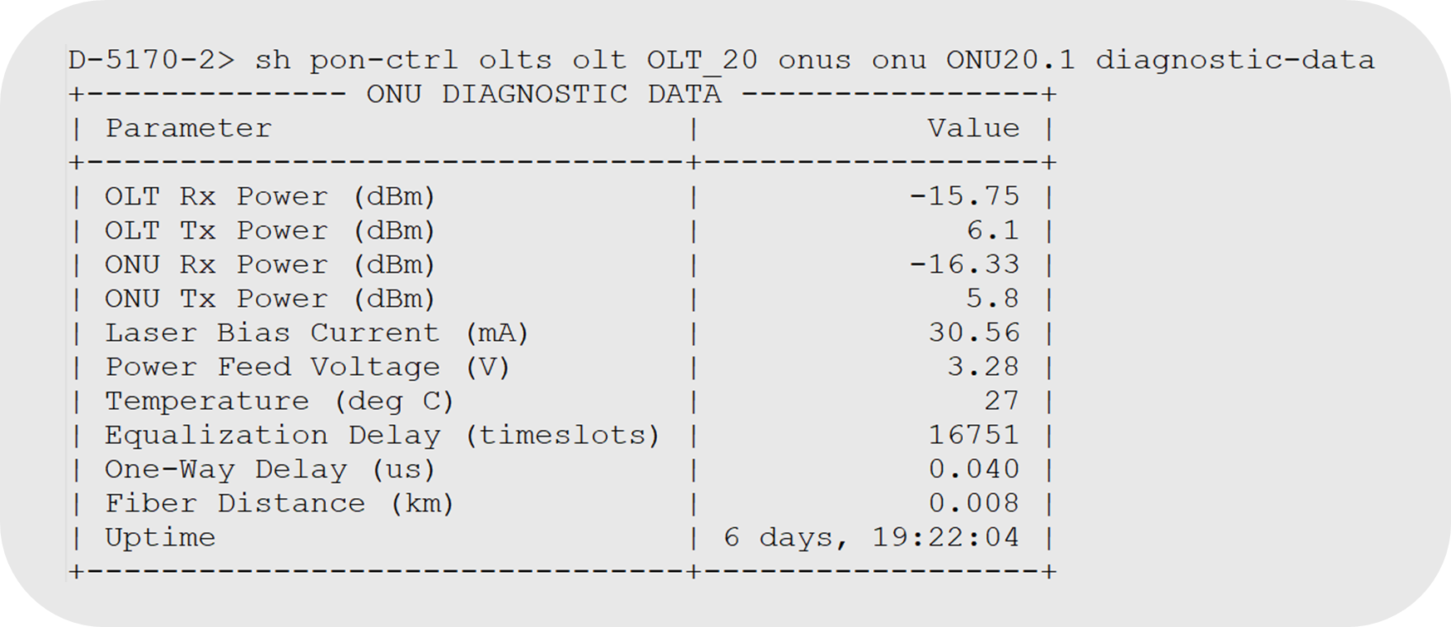

-End of Lab 5

## Lab 6: ONU UNI Port Configuration

### Objectives

* Adding a UNI port on an ONU using CLI
* Verify the status of a UNI port on an ONU
* Delete a configured UNI port on an ONU

### Task 1: Configure a UNI port on a specific ONU

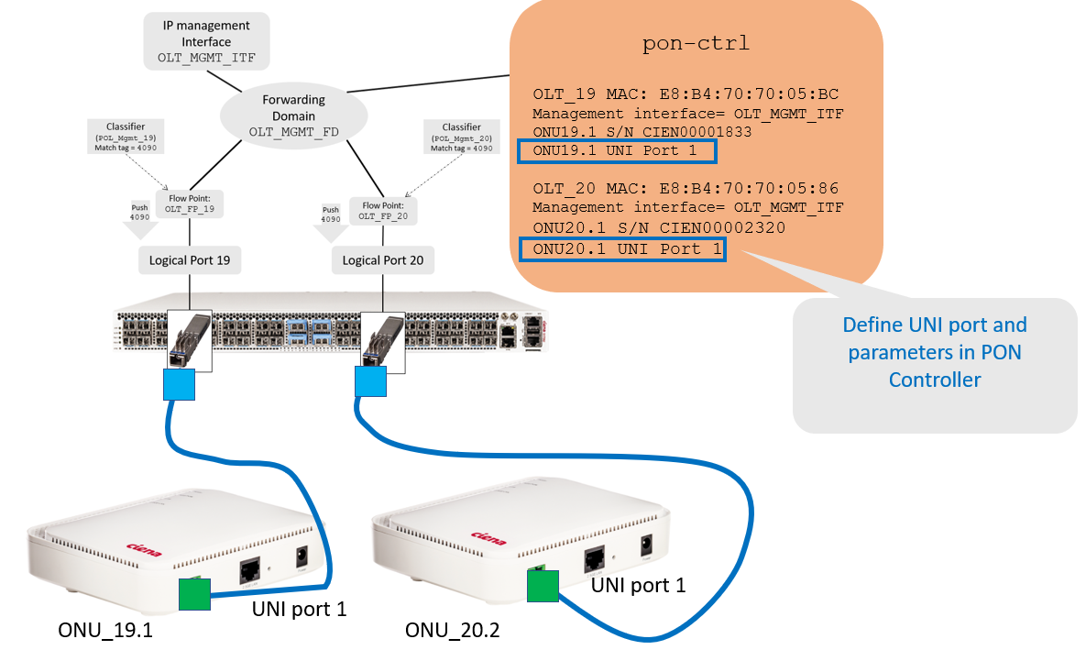

1. As per the OLT/ONU UNI port assigned to your team and using the serial number of the ONU connected to your port, execute the following commands:
   1. OLT_19:
2. D-5170-2> **config**
3. diag@5170-2# **pon-ctrl onus onu ONU19.1 OLT_19 uni-ports uni-port 1 admin-state enabled description “UNI Port 1” duplex full max-frame-size 9216 speed 1Gb stats-collection enabled**
   1. OLT_20
4. D-5170-2> **config**
5. diag@D-5170-2# **pon-ctrl onus onu ONU20.1 OLT_20 uni-ports uni-port 1 admin-state enabled description “UNI Port 1” duplex full max-frame-size 9216 speed 1Gb stats-collection enabled**

Note: A maximum of 256 UNI ports can be configured with statistics collection enabled.

### Task 2: Verify the status of a UNI port on a specific ONU

1. Display the operational status and information of a newly configured UNI port on a specific ONU:

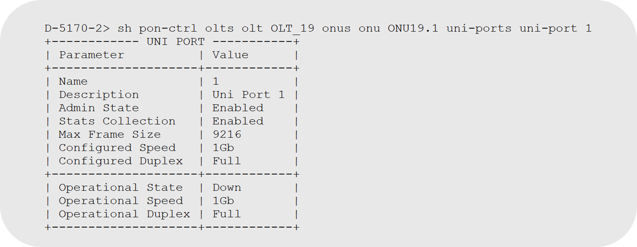

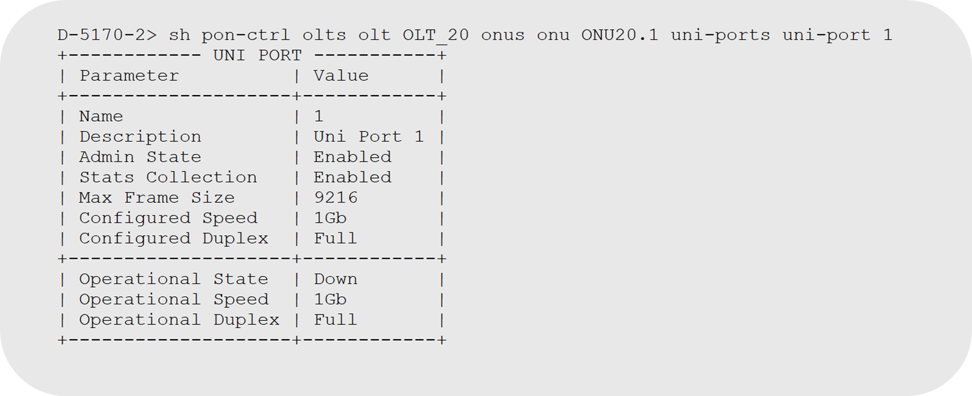

Note: These UNI ports will only be active if lab gear has a connection to ONU UNI port.

**-End Lab 6**

### Informational: How to delete a UNI port on a specific ONU

1. As per the port assigned to your team and using the serial number of the ONU connected to your port, execute the following commands:
   1. OLT_19:
2. D-5170-2> **config**
3. diag@D-5170-2# **no** **pon-ctrl onus onu ONU19.1 OLT_19 uni-ports uni-port 1** 
   1. OLT_20
4. D-5170-2> **config**
5. diag@D-5170-2# **no** **pon-ctrl onus onu ONU20.1 OLT_20 uni-ports uni-port 1**
6. To delete all UNI ports on a specific ONU, execute the following commands:
   1. OLT_19:
7. D-5170-2> **config**
8. diag@D-5170-2# **no** **pon-ctrl onus onu ONU19.1 OLT_19 uni-ports** 
   1. OLT_20
9. D-5170-2> **config**
10. diag@D-5170-2# **no** **pon-ctrl onus onu ONU20.1 OLT_20 uni-ports**

## Lab 7: PON Connection Configuration

### Objectives

* Explore PON Connection Components
* Configure the SLA Profile, NNI Network, Datalink and PON connection
* Verify the SLA Profile, NNI Network, Datalink and PON connection
* Delete SLA Profiles, NNI Networks, Datalinks and PON connections

### Task 1: Explore PON Connection Components

1. Your instructor will explain the concept of SLA profile, Datalink, NNI Network and PON Connection.

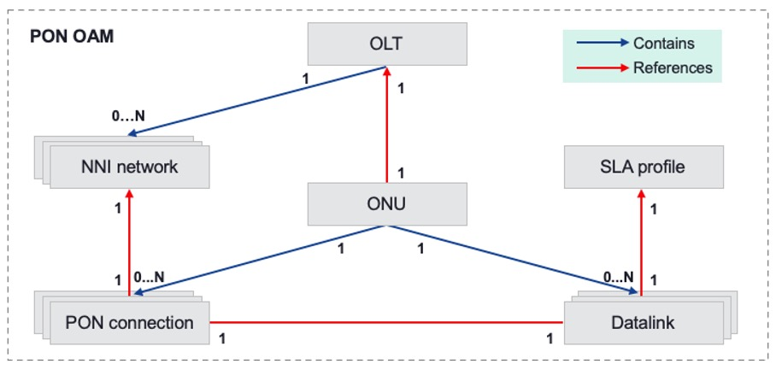

1. Your instructor will explain the two Datalink types (EPL and EVPL) that are supported with SAOS 10.

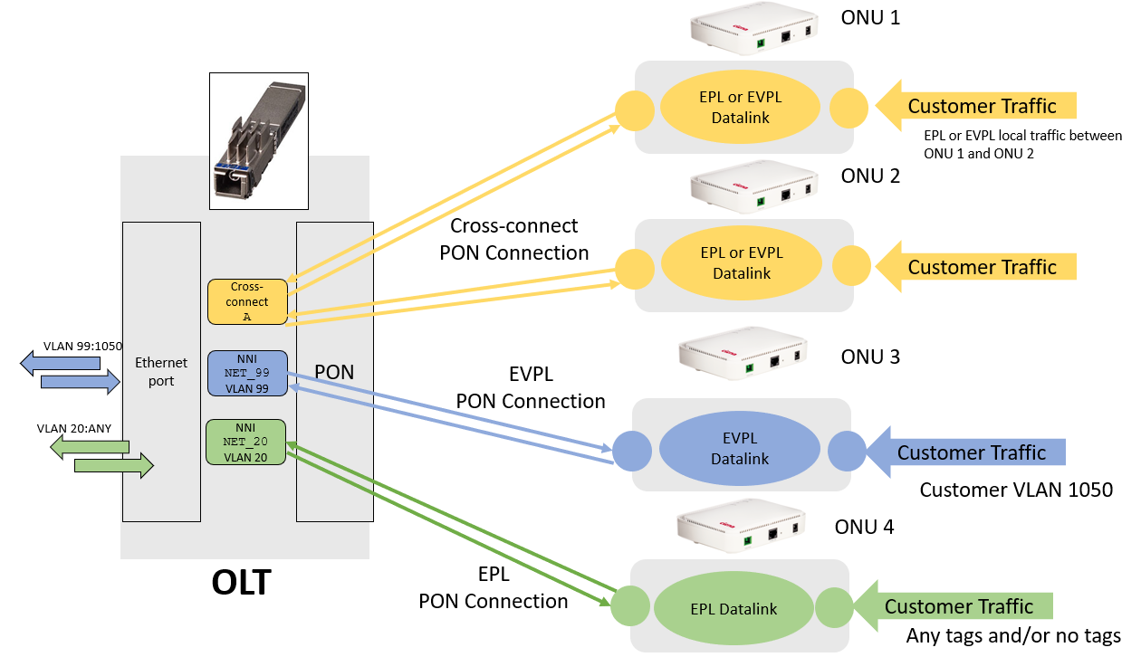

Note: Information shown in this graphic is to show the concepts of Datalinks and PON connections and is not to be used for lab exercise.

### Task 2: Configure and verify the SLA Profile and NNI Network

1. As per the OLT assigned to your team, execute the following commands:
   1. OLT_19:

Provision the SLA Profile

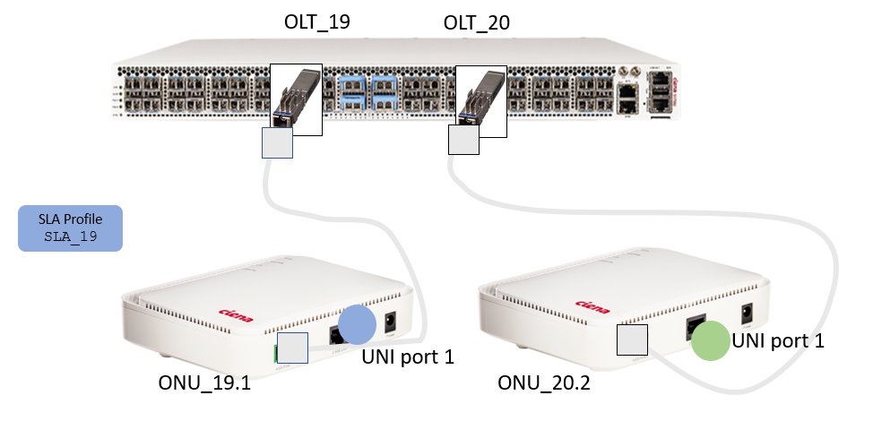

1. D-5170-2> **config**
2. diag@D-5170-2# **pon-ctrl sla-profiles sla-profile SLA_19 up-fixed-rate 0 up-guaranteed-rate 128 up-guaranteed-max-burst 409600 up-best-effort-rate 1000000 up-best-effort-max-burst 409600 up-priority 1 up-service-limit 128 up-min-grant-period 0 up-max-grant-period 10 down-guaranteed-rate 128 down-guaranteed-max-burst 262144 down-best-effort-rate 1000000 down-best-effort-max-burst 245760**

Provision the NNI Network

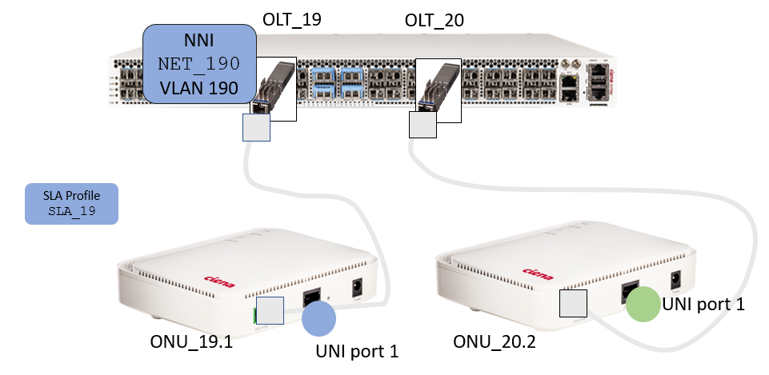

1. D-5170-2> **config**
2. diag@D-5170-2# **pon-ctrl olts olt OLT_19 nni-networks nni-network NET_190 match-stag 190 match-ctag-1 65535 match-ctag-2 65535 tag-action pop tag-action-pop 1**

Note: NNI Networks use an attribute called a “Flooding Link”. By default, a flooding link is created when defining an NNI. A flooding link is used to carry any unlearned unicast traffic as well as multicast and broadcast traffic. You can disable this link by adding **flooding-link disabled** to the command above. If disabled, any unlearned unicast, multicast or broadcast traffic will be transmitted on the **first** datalink added to the NNI network through a PON connection.

If disabled, no more than one PON connection and datalink can be connected to the NNI network. When the flooding link is disabled, any attempt to create a 2nd PON connection will result in an error. Further, this parameter cannot be modified once NNI is created. Changing this attribute, requires the NNI to be deleted and recreated.

* 1. OLT_20:

Provision the SLA Profile

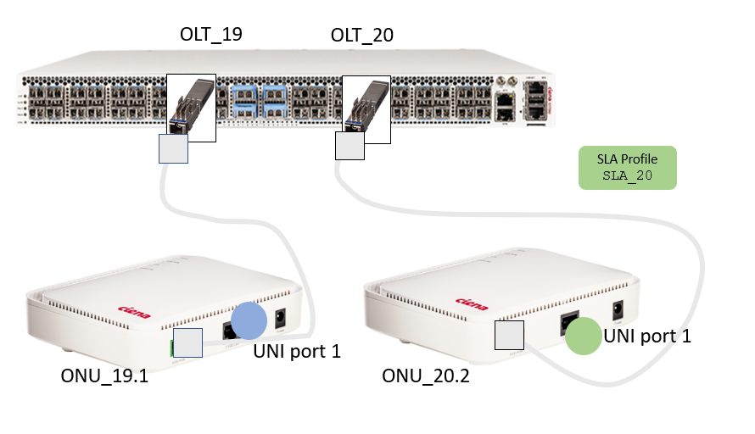

1. D-5170-2> **config**
2. diag@D-5170-2# **pon-ctrl sla-profiles sla-profile SLA_20 up-fixed-rate 0 up-guaranteed-rate 128 up-guaranteed-max-burst 409600 up-best-effort-rate 1000000 up-best-effort-max-burst 409600 up-priority 1 up-service-limit 128 up-min-grant-period 0 up-max-grant-period 10 down-guaranteed-rate 128 down-guaranteed-max-burst 262144 down-best-effort-rate 1000000 down-best-effort-max-burst 245760**

Provision the NNI Network

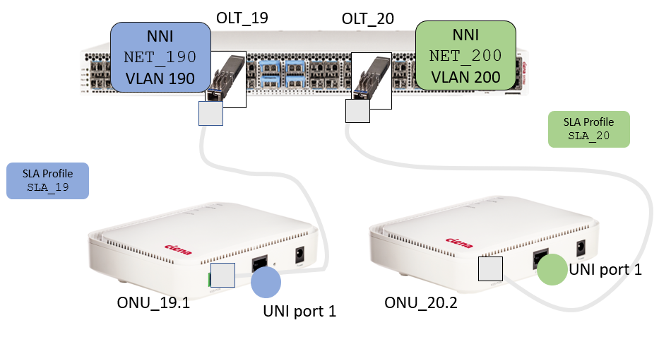

1. D-5170-2> **config**
2. diag@D-5170-2# **pon-ctrl olts olt OLT_20 nni-networks nni-network NET_200 match-stag 200 match-ctag-1 65535 match-ctag-2 65535 tag-action pop tag-action-pop 1**

Note: NNI Networks use an attribute called a “Flooding Link”. By default, a flooding link is created when defining an NNI. A flooding link is used to carry any unlearned unicast traffic as well as multicast and broadcast traffic. You can disable this link by adding **flooding-link disabled** to the command above. If disabled, any unlearned unicast, multicast or broadcast traffic will be transmitted on the **first** datalink added to the NNI network through a PON connection.

If disabled, no more than one PON connection and datalink can be connected to the NNI network. When the flooding link is disabled, any attempt to create a 2nd PON connection will result in an error. Further, this parameter cannot be modified once NNI is created. Changing this attribute, requires the NNI to be deleted and recreated.

1. Verify the SLA profiles with this common command:

### 

1. Display a summary of all NNI Networks on a specific OLT with this command:

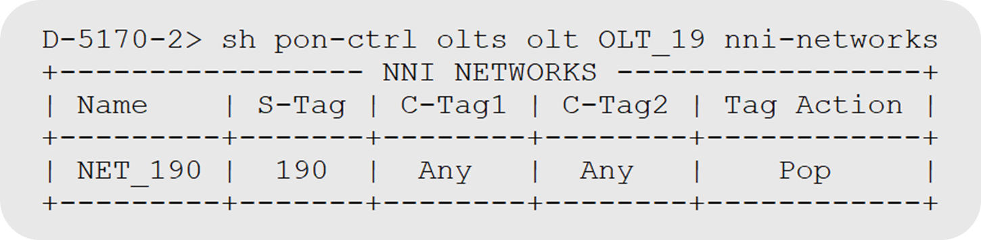

1. Display a specific NNI Network for a specific OLT with this command:

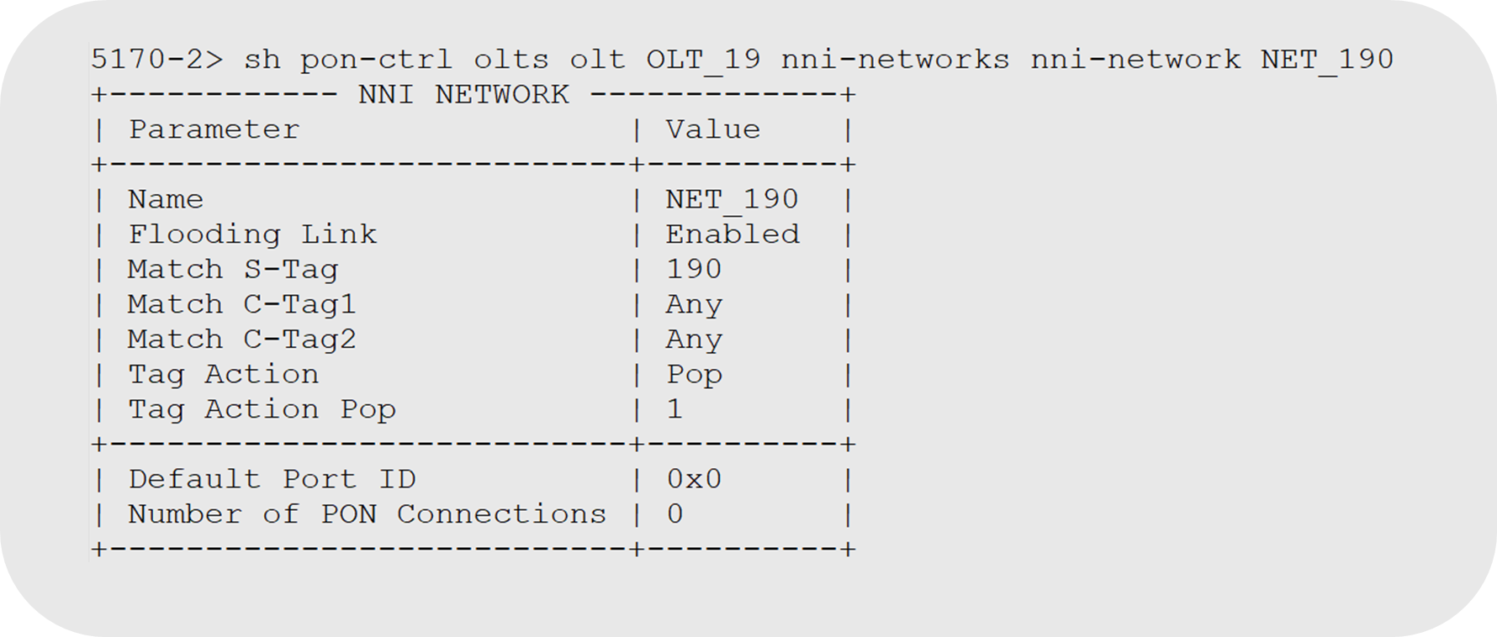

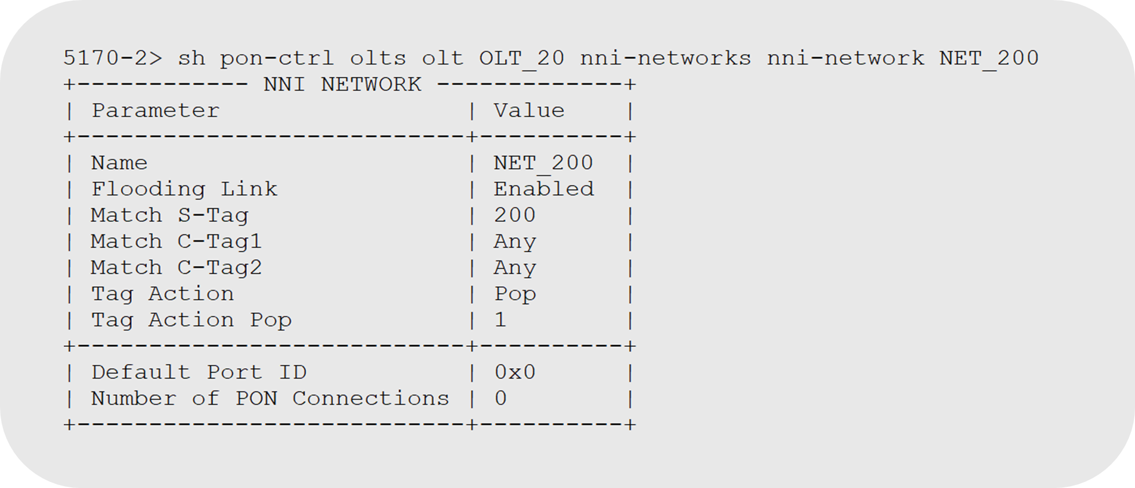

### Task 3: Configure and verify the Datalink – EPL or EVPL

Since an EPL service encompasses all traffic on the configured port(s), only one EPL service can be configured on a UNI port.

1. Provision an **EPL** Datalink Service on UNI port 1 using these commands:
   1. OLT_19:

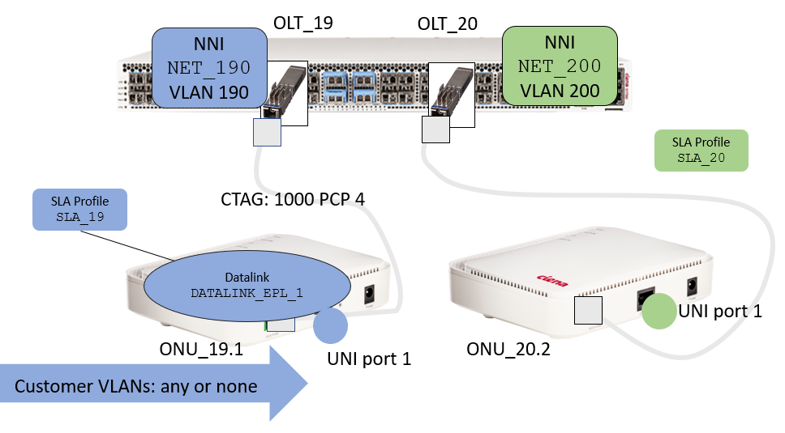

1. D-5170-2> **config**
2. diag@D-5170-2# **pon-ctrl onus onu ONU19.1 OLT_19 datalinks datalink DATALINK_EPL_1 admin-state enabled sla-profile SLA_19 add-ctag 1000 add-ctag-pcp 4 uni-ports 1**
   1. OLT_20:

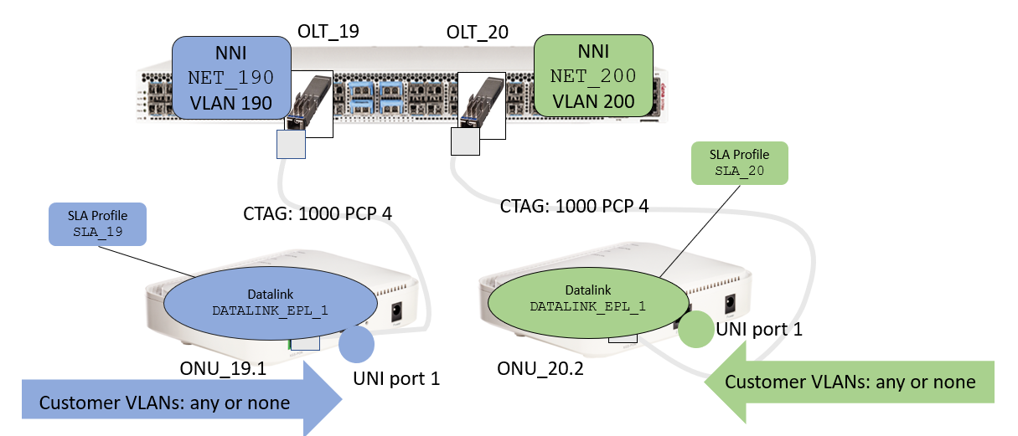

1. D-5170-2> **config**
2. diag@D-5170-2# **pon-ctrl onus onu ONU20.1 OLT_20 datalinks datalink DATALINK_EPL_1 admin-state enabled sla-profile SLA_20 add-ctag 1000 add-ctag-pcp 4 uni-ports 1**
3. Delete the EPL Datalink Service on UNI port before continuing, using these commands:

a. OLT_19:

1. D-5170-2> **config**
2. diag@D-5170-2# **no pon-ctrl onus onu ONU19.1 OLT_19 datalinks datalink DATALINK_EPL_1**

b. OLT_20:

1. D-5170-2> **config**
2. diag@D-5170-2# **no pon-ctrl onus onu ONU20.1 OLT_20 datalinks datalink DATALINK_EPL_1**
3. Provision an EVPL Datalink Service on UNI port 1 for VLAN IDs 100, 101 and 102, using these commands:

a. OLT_19:

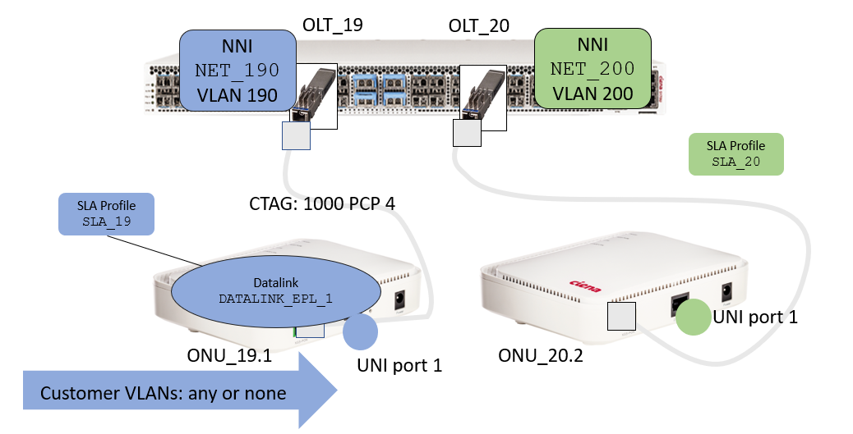

1. D-5170-2> **config**
2. diag@D-5170-2# **pon-ctrl onus onu ONU19.1 OLT_19 datalinks datalink DATALINK_EVPL_1 admin-state enabled sla-profile SLA_19 add-ctag 1000 add-ctag-pcp 4 uni-ports 1 vlan-ids 100 101 102**
   1. OLT_20:

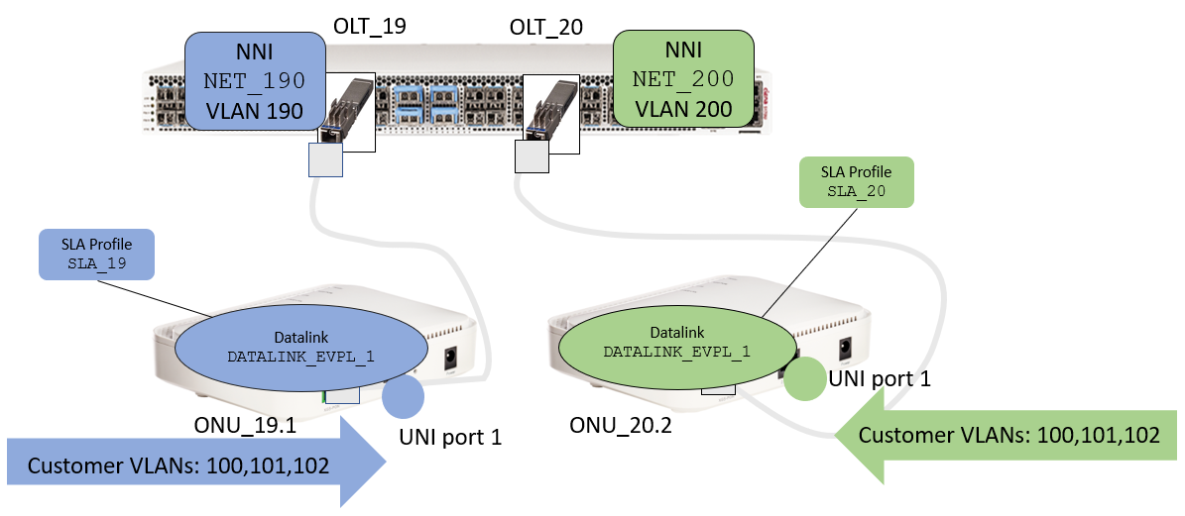

1. D-5170-2> **config**
2. diag@D-5170-2# **pon-ctrl onus onu ONU20.1 OLT_20 datalinks datalink DATALINK_EVPL_1 admin-state enabled sla-profile SLA_20 add-ctag 1000 add-ctag-pcp 4 uni-ports 1 vlan-ids 100 101 102**
3. Verify the various datalinks created under the respective OLTs, using these ‘show’ commands:

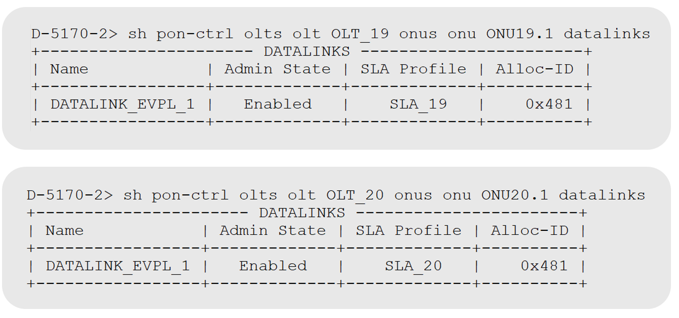

### Task 4: Configure and verify the PON Connection

PON connections link a datalink on the ONU to an NNI network on the OLT. Each PON connection created belongs to a specific ONU. An ONU can have 0 ... N PON connections configured. Each PON connection must reference one NNI network and one datalink.

1. As per the OLT assigned to your team, execute the following commands to provision the PON connection, using the NNI Network and the EVPL Datalink Service provisioned earlier:
2. OLT_19:

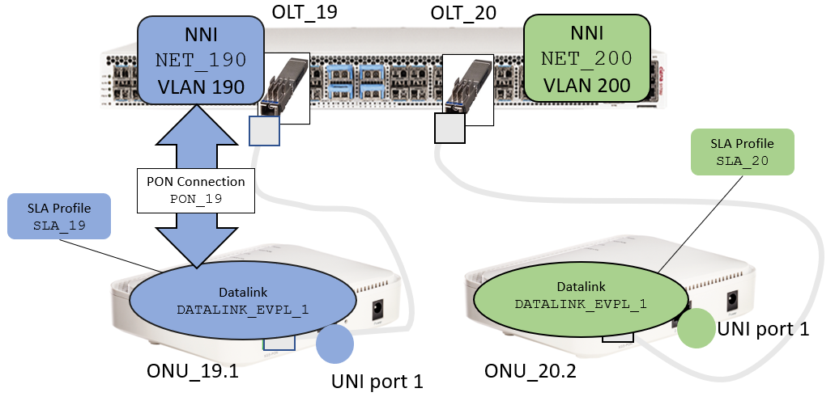

1. D-5170-2> **config**
2. diag@D-5170-2# **pon-ctrl onus onu ONU19.1 OLT_19 pon-connections pon-connection PON_19 datalink DATALINK_EVPL_1 nni-network NET_190 match-stag 0 match-ctag-1 1000 match-ctag-2 0 tag-action push tag-action-stag 190**
3. OLT_20:

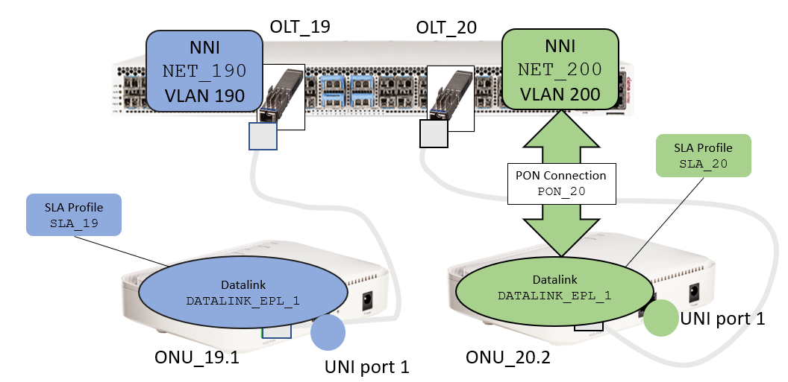

1. D-5170-2> **config**
2. diag@D-5170-2# **pon-ctrl onus onu ONU20.1 OLT_20 pon-connections pon-connection PON_20 datalink DATALINK_EVPL_1 nni-network NET_200 match-stag 0 match-ctag-1 1000 match-ctag-2 0 tag-action push tag-action-stag 200**
3. Verify the created PON connections, using the following command on the respective OLT:

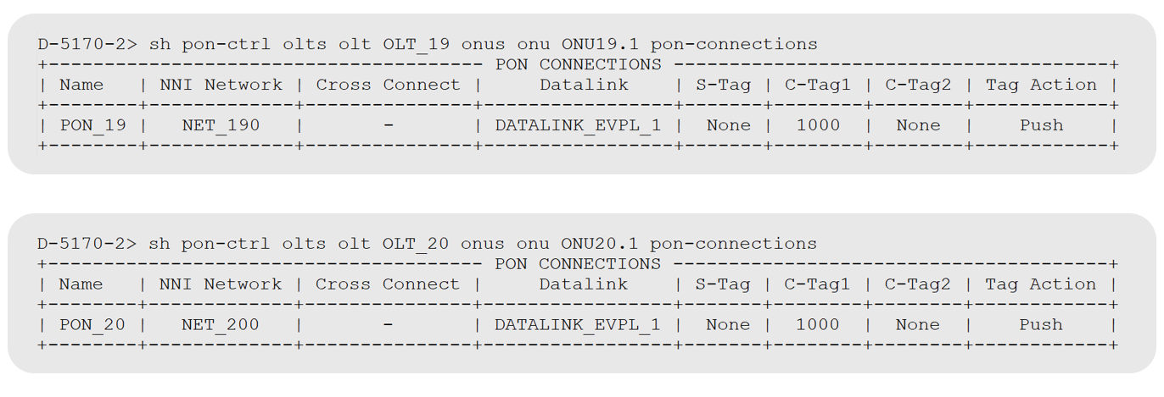

-End of Lab 7

### Informational: How to delete PON services including the configured SLA Profiles, NNI Networks, Datalinks and PON Connections

Deleting the objects, we previously created, needs to happen in the reverse order of their creation (due to dependencies).

1. Delete a specific PON Connection

a. OLT_19:

1. D-5170-2> **config**
2. diag@D-5170-2# **no pon-ctrl onus onu ONU19.1 OLT_19 pon-connections pon-connection PON_19**

b. OLT_20:

1. D-5170-2> **config**
2. diag@D-5170-2# **no pon-ctrl onus onu ONU20.1 OLT_20 pon-connections pon-connection PON_20**
3. Delete all PON Connections for a specific OLT:

a. OLT_19:

1. D-5170-2> **config**
2. diag@D-5170-2# **no pon-ctrl onus onu ONU19.1 OLT_19 pon-connections**

b. OLT_20:

1. D-5170-2> **config**
2. diag@D-5170-2# **no pon-ctrl onus onu OLT_20 OLT_20 pon-connections**
3. Delete a specific Datalink on a specific OLT

a. OLT_19:

1. D-5170-2> **config**
2. diag@D-5170-2# **no pon-ctrl onus onu ONU19.1 OLT_19 datalinks datalink DATALINK_EVPL_1**

b. OLT_20:

1. D-5170-2> **config**
2. diag@D-5170-2# **no pon-ctrl onus onu ONU20.1 OLT_20 datalinks datalink DATALINK_EVPL_1**
3. Delete all Datalinks of a specific OLT:

a. OLT_19:

1. D-5170-2> **config**
2. diag@D-5170-2# **no pon-ctrl onus onu ONU19.1 OLT_19 datalinks**

b. OLT_20:

1. D-5170-2> **config**
2. diag@D-5170-2# **no pon-ctrl onus onu ONU20.1 OLT_20 datalinks**
3. Delete a specific NNI Network of a specific OLT:

a. OLT_19:

1. D-5170-2> **config**
2. diag@D-5170-2# **no pon-ctrl olts olt OLT_19 nni-networks nni-network NET_190**

b. OLT_20:

1. D-5170-2> **config**
2. diag@D-5170-2# **no pon-ctrl olts olt OLT_20 nni-networks nni-network NET_200**
3. Delete all NNI Networks, for a specific OLT:

a. OLT_19:

1. D-5170-2> **config**
2. diag@D-5170-2# **no pon-ctrl olts olt OLT_19 nni-networks**

b. OLT_20:

1. D-5170-2> **config**
2. diag@D-5170-2# **no pon-ctrl olts olt OLT_20 nni-networks**
3. Delete a specific SLA-profile

a. OLT_19:

1. D-5170-2> **config**
2. diag@D-5170-2# **no pon-ctrl sla-profiles sla-profile SLA_19**

b. OLT_20:

1. D-5170-2> **config**
2. diag@D-5170-2# **no pon-ctrl sla-profiles sla-profile SLA_20**
3. Delete all SLA-profiles (for all OLTs):
4. D-5170-2> **config**
5. diag@D-5170-2# **no pon-ctrl sla-profiles**

## Lab 8: PON Operations Tasks

### Objectives

* Verify OLT diagnostic information
* Verify and clear OLT statistics
* Verify and clear ONU datalink statistics
* Reset OLT
* Reset ONU
* Allowing and disallowing ONU admission control

### Task 1: Verify OLT diagnostic information

SAOS 10 provides the following diagnostic information per OLT available:

* ASIC temperature (Celsius)
* Transceiver (XCVR) temperature (Celsius)
* Laser temperature (Celsius)
* VCC (mV)
* TEC current (uA)
* Transmit bias current (uA)
* Idle receive power (dBM) — In a normal operating system, this reads -40dBm.
* Transmit power (dBM)
* Last shutdown reason (string) — Reason for the last shutdown of the OLT’s laser
* Is laser shutdown (boolean) — True indicates the OLT’s laser is currently shut down. False indicates that the OLT’s laser is currently active.

1. To show the diagnostic information of the configured OLT, you can use this command:

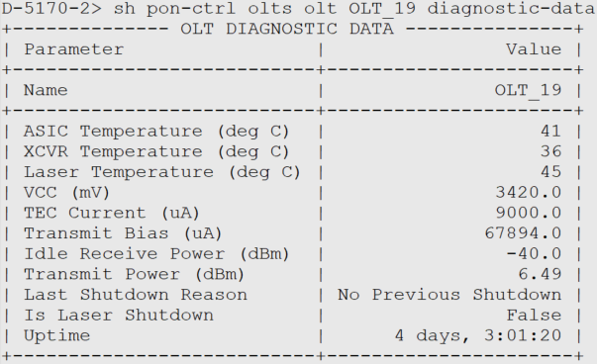

### Task 2: Verify and Clear OLT Statistics

1. As per the nodes assigned to your team, execute the following commands in order to display and clear the OLT statistics:
   1. OLT_19:
2. D-5170-2> **show pon-ctrl olts olt OLT_19 statistics**
3. D-5170-2> **clear pon-ctrl olts olt OLT_19 statistics**
   1. OLT_20
4. D-5170-2> **show pon-ctrl olts olt OLT_20 statistics**
5. D-5170-2> **clear pon-ctrl olts olt OLT_20 statistics**

### Task 3: Verify and Clear the ONU Datalink Statistics

1. As per the nodes assigned to your team, execute the following commands in order to display and clear the ONT datalink statistics:
   1. OLT_19:
2. D-5170-2> **show pon-ctrl olts olt OLT_19 onus onu ONU19.1 datalinks datalink DATALINK_1 statistics**
3. D-5170-2> **clear pon-ctrl olts olt OLT_19 onus onu ONU19.1 datalinks datalink DATALINK_1 statistics**
   1. OLT_20
4. D-5170-2> **show pon-ctrl olts olt OLT_20 onus onu ONU20.1 datalinks datalink DATALINK_1 statistics**
5. D-5170-2> **clear pon-ctrl olts olt OLT_20 onus onu ONU20.1 datalinks datalink DATALINK_1 statistics**

### Task 4: Verify and Clear the ONU UNI Port Statistics

1. As per the nodes assigned to your team, execute the following commands in order to display and clear the ONU UNI port statistics:
   1. OLT_19:
2. D-5170-2> **show pon-ctrl olts olt OLT_19 onus onu ONU19.1 uni-ports uni-port 1 statistics**
3. D-5170-2> **clear pon-ctrl olts olt OLT_19 onus onu ONU19.1 uni-ports uni-port 1 statistics**
   1. OLT_20
4. D-5170-2> **show pon-ctrl olts olt OLT_20 onus onu ONU20.1 uni-ports uni-port 1 statistics**
5. D-5170-2> **clear pon-ctrl olts olt OLT_20 onus onu ONU20.1 uni-ports uni-port 1 statistics**

### Task 5: Reset and Verify OLT

Verify the state of the OLT before issuing the reset command:

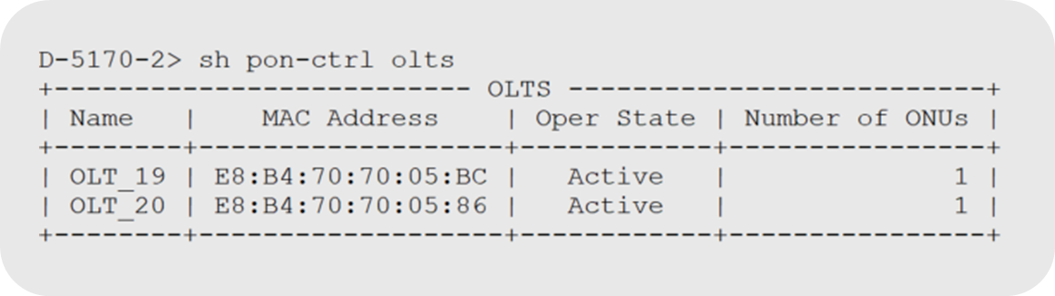

As per the nodes assigned to your team, execute the following commands:

* 1. OLT_19:

1. D-5170-2> **pon-ctrl reset olts olt OLT_19**
   1. OLT_20
2. D-5170-2> **pon-ctrl reset olts olt OLT_20**

### Immediately after executing the command, verify the altered state of the OLTs:

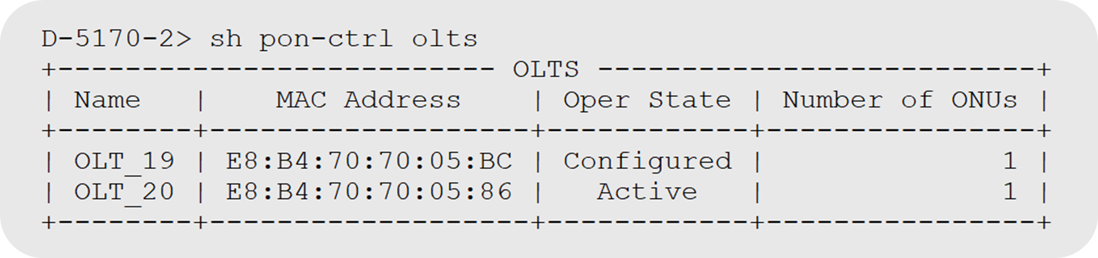

1. After 2 minutes, verify the state again:



### Task 6: Reset the ONU

Verify the state of the OLT before issuing the reset command:

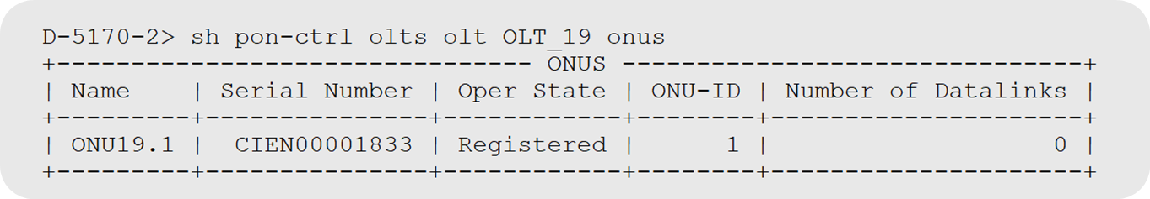

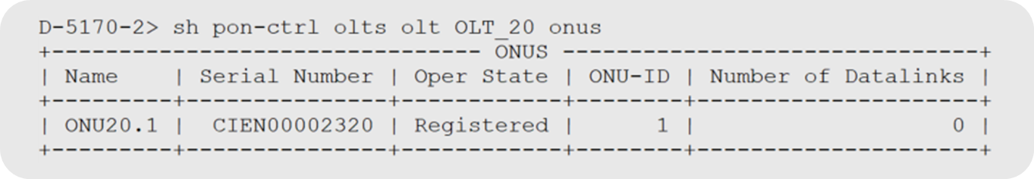

As per the nodes assigned to your team, execute the following commands:

* 1. OLT_19: resetting ONT_19.1

1. D-5170-2> **pon-ctrl reset olts olt OLT_19 onus onu ONU19.1**
   1. OLT_20: resetting ONT_20.1
2. D-5170-2> **pon-ctrl reset olts olt OLT_20 onus onu ONU20.1**

### Immediately after executing the command, verify the altered state of the OLTs:

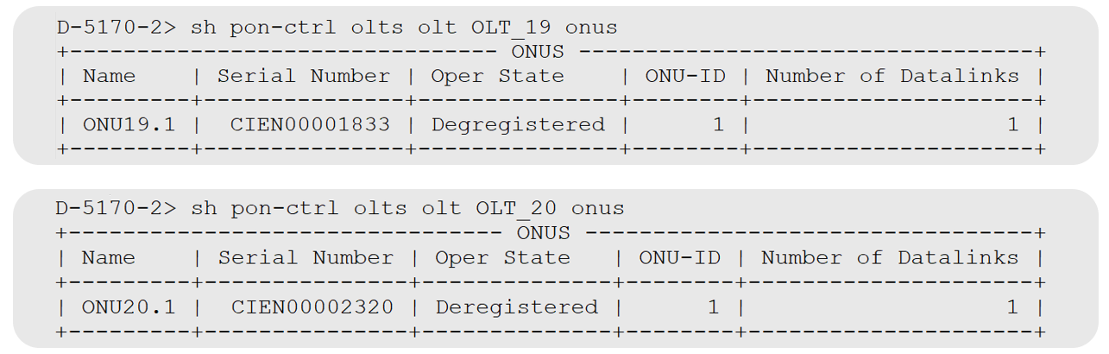

1. You can find the detailed reason for the ‘Deregistered’ state using this show command (example shown for ONU20.1 on OLT_20):

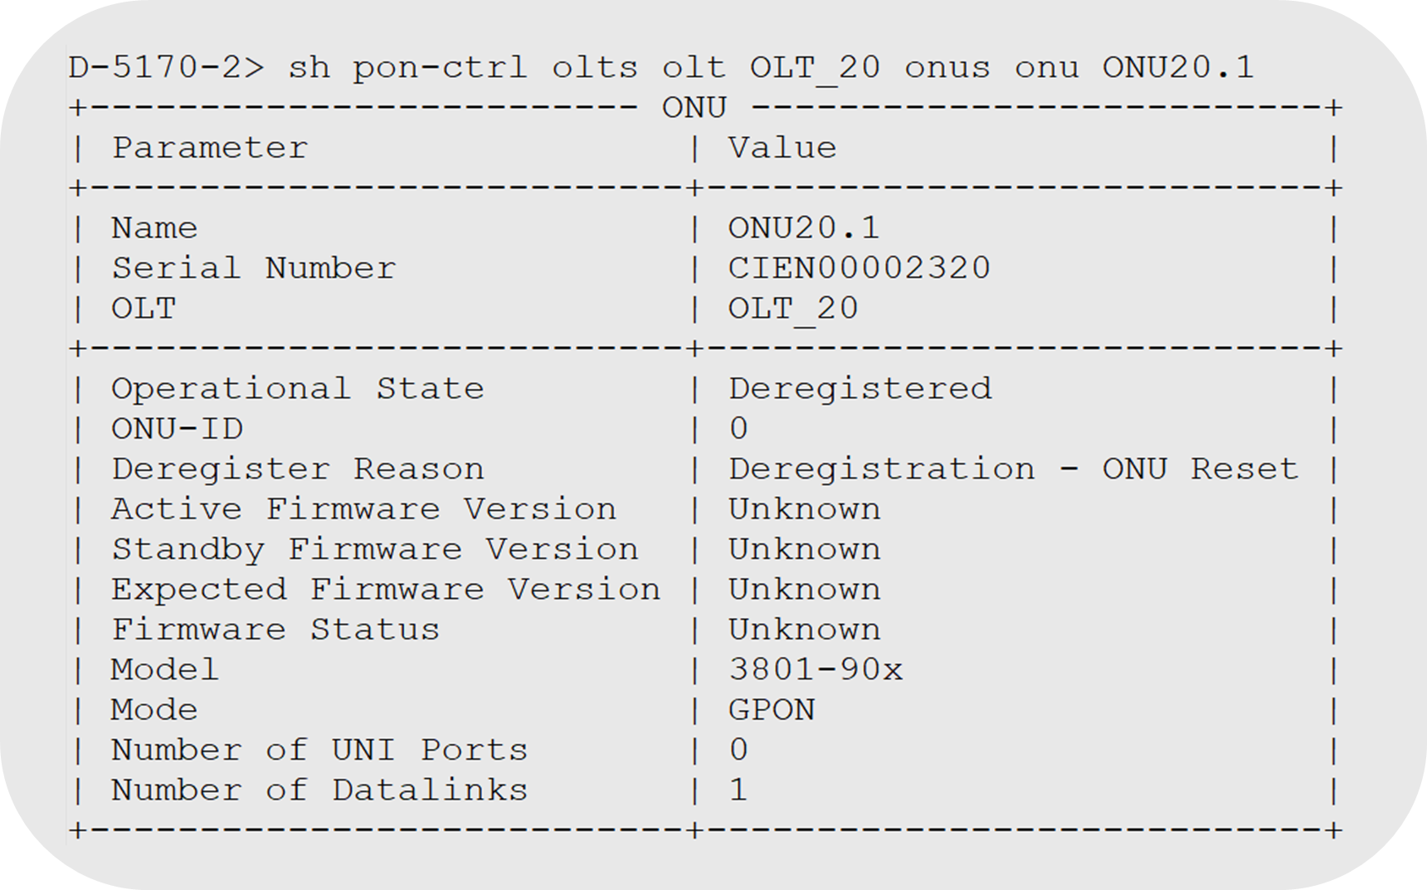

1. After 2 minutes, verify the state again:

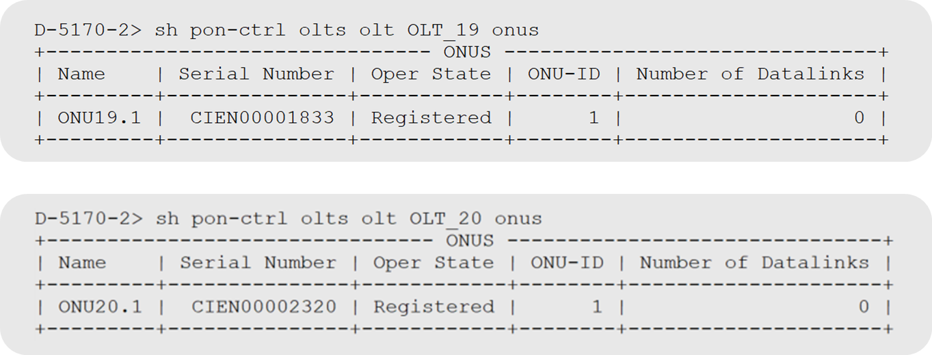

### Task 7: Allowing and disallowing ONU admission control

ONU admission control is about controlling whether an ONU is allowed to be registered on the PON.

1. In order to allow admission control for your ONU, execute the following commands:
2. OLT_19:
3. D-5170-2> **pon-ctrl admission-control set olts olt OLT_19 onus onu ONU19.1 registration-allowed true**
4. OLT_20
5. D-5170-2> **pon-ctrl admission-control set olts olt OLT_20 onus onu ONU20.1 registration-allowed true**
6. In order to disallow admission control for your ONU, execute the following commands:
7. OLT_19:
8. D-5170-2> **pon-ctrl admission-control set olts olt OLT_19 onus onu ONU19.1 registration-allowed false**
9. OLT_20
10. D-5170-2> **pon-ctrl admission-control set olts olt OLT_20 onus onu ONU20.1 registration-allowed false**

-End of Lab 8

## Lab 9 : Events and Alarms

### Objectives

* ONU Deregistered Alarm
* SFP Transceiver Alarms
* ONU Port Loss of Signal Alarm
* ONU Firmware mismatch
* OLT Firmware mismatch
* OLT Unreachable
* OLT RX LOS
* Events

There are PON specific alarms defined, which we will describe here, as well as PON XCVR alarms (transceiver) which are reported using the standard SAOS XCVR alarms.

### Task 1: ONU Deregistered Alarm

1. The ONU deregistered alarm is set when the ONU operational state transitions from registered to deregistered. This alarm is cleared when the ONU operational state transitions back to registered. An example follows:

**Show alarm list active-alarms alarm-type all**

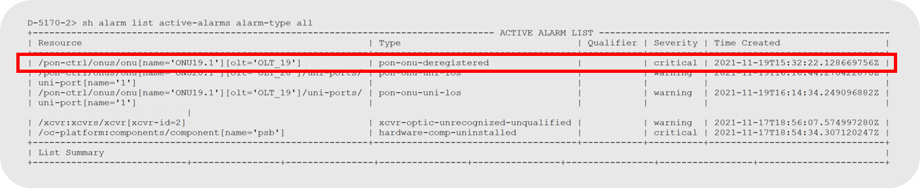

### Task 2: Explore SFP Transceiver Alarms

1. There are standard SFP transceiver alarms generated for the following SFP warning/error events:

|  |  |
| --- | --- |
| **SFP Transceiver event and alarm** | **Meaning** |
| xcvr-over-temp | Transceiver high temperature threshold crossed |
| xcvr-under-temp | Transceiver low temperature threshold crossed |
| xcvr-rx-power-hi | Transceiver high rx power threshold crossed |
| xcvr-rx-power-lo | Transceiver low rx power threshold crossed |
| xcvr-tx-power-hi | Transceiver high tx power threshold crossed |
| xcvr-voltage-hi | Transceiver high voltage threshold crossed |
| xcvr-voltage-lo | Transceiver low voltage threshold crossed |
| xcvr-bias-hi | Transceiver high bias current threshold crossed |
| xcvr-bias-lo | Transceiver low bias current threshold crossed |

### Task 3: ONU Port Loss of Signal Alarm

1. The ONU UNI Port Loss of Signal alarm is set when the ONU UNI port operational state transitions from Up to Down. It is cleared when the ONU UNI port operational state transitions back to Up. An example is shown here:

**Show alarm list active-alarms alarm-type all**

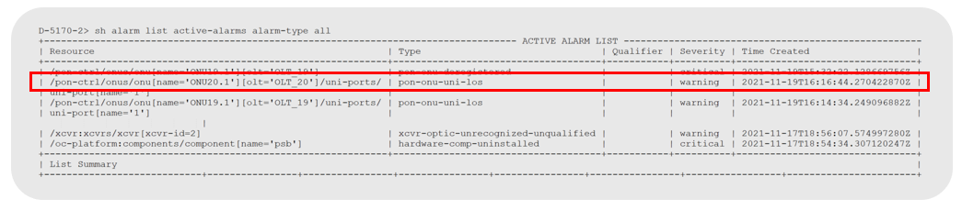

### Task 4: ONU Firmware Mismatch Alarm

1. The ONU firmware mismatch alarm occurs when the ONU’s running firmware version does not match the expected firmware version. The alarm is cleared when the ONU’s running firmware version matches the expected firmware version.

**Note**: This alarm is only generated for ONUs which have a specified “expected firmware version”. Currently this only includes Ciena ONUs.

**Show alarm list active-alarms alarm-type all**

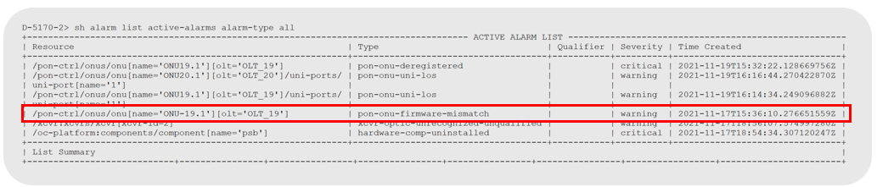

### Task 5: OLT Firmware Mismatch Alarm

1. The OLT firmware mismatch alarm occurs when the OLT’s running firmware version does not match the expected firmware version for the SAOS 10 release that is running on the OLT hosting device. The alarm is cleared when the OLT’s running firmware version matches the expected firmware version.

.

### Task 6: OLT Unreachable

1. The alarm is raised when the PON controller cannot communicate with an OLT that has been defined in the PON controller. This alarm could indicate a failure in the PON management infrastructure such as if a component (VLAN, Type value, FD, FP etc.) of the management network were incorrectly modified or removed. This could also occur If priority values for the PONmanagement traffic were not set high enough and there was traffic congestion experienced in the network.

### Task 7: OLT RX LOS

1. The alarm is raised when the optical signal to an OLT is either below the minimum RX threshold or above the RX overload value for the OLT.
   1. The OLT has a 32dB optical budget with FEC enabled.
   2. The OLT launches at +4dBm and both the OLT and ONUs receive at -28dBm.
   3. FEC adds +5 dB of sensitivity to the receiver (-23dBm without FEC, -28dBm with FEC).

SAOS 10 supports the reporting of the following types of PON related events:

|  |  |
| --- | --- |
| **Events** | **Meaning** |
| OLT Discovered | A new unconfigured OLT is discovered on the L3 interface |
| ONU Discovered | A new unconfigured ONU is discovered on an active OLT. |
| OLT Operational State Change | The operational state of an OLT changes. |
| ONU Operational State Change | The operational state of an ONU changes. |
| ONU UNI Port Operational State Change | The operational state of an ONU UNI Port changes. |
| RADIUS Server Operation State Change | The operational state of a RADIUS server changes. |
| DHCP Relay Operational State Change | The operational state of a DHCP Server changes. |
| Authentication Operational State Change | The operational state of an Authentication Server changes. |

End of Lab

Appendix: PON Firmware Updates:

### OLT Firmware Updates:



### OLT firmware upgrades SAOS 10.6.0 and above

OLTs inserted into a SAOS 10 chassis **running SAOS 10.6.0 and newer will automatically upgrade** or downgrade to the expected firmware version for the SAOS 10 Release running on the SAOS 10 device hosting the inserted OLT.

### OLT firmware upgrades prior to 10.6.0:

If OLT hosting SAOS 10 device is running a SAOS 10 release prior to 10.6.0, you must manually install the OLT firmware. You have two options:

* Option 1 – install and immediately activate firmware
* Option 2 – install and defer activation of firmware

### Install and immediately activate firmware (SAOS 10 releases prior to 10.6.0 only)

1. Install the OLT firmware with immediate activation of the firmware.
   1. OLT_19:
2. D-5170-2> **pon-ctrl firmware install olts olt OLT_19**
   1. OLT_20:
3. D-5170-2> **pon-ctrl firmware install olts olt OLT_20**

**Install and defer activation of firmware (SAOS 10 releases prior to 10.6.0 only)**

1. Install the firmware but defer the activation of the firmware.
   1. OLT_19:
2. D-5170-2> **pon-ctrl firmware install olts olt OLT_19 defer-activation**
   1. OLT_20:
3. D-5170-2> **pon-ctrl firmware install olts olt OLT_20 defer-activation**

Perform Activation:

* Activation can be manually initiated at any time after firmware is installed. (example of OLT_19):

1. Activate the OLT:
   1. OLT_19:
2. 5170-2> **pon-ctrl firmware activate olts olt OLT_19 firmware-version R1.3.1**
   1. OLT_20:
3. 5170-2> **pon-ctrl firmware activate olts olt OLT_20 firmware-version R1.3.1**

### ONU firmware upgrades:

Ciena supports two types of ONUs. Ciena ONUs and third-party ONUs. In our lab environment we use Ciena ONUs. When using Ciena ONUs it is important to know that they also have an expected release that matches with the SAOS 10 release. However, unlike the OLT firmware, ONU firmware is NOT part of a SAOS 10 release. The firmware for Ciena ONUs must be loaded onto the SAOS 10 device acting as the PON controller. Consult Ciena technical documentation on firmware versions for a specific SAOS 10 release.

For Third-party ONUs the ONU image file must be also manually loaded. Consult Ciena technical documentation for information regarding support for specifics on a given third-party ONU device. If model is supported, consult the ONU technical documentation for specifics firmware version supported that is compatible with the Ciena PON solution.

Use the following command to view ONU firmware library on the SAOS 10 Device. You must manually transfer the ONU image file to the SAOS 10 device acting as the PON controller.

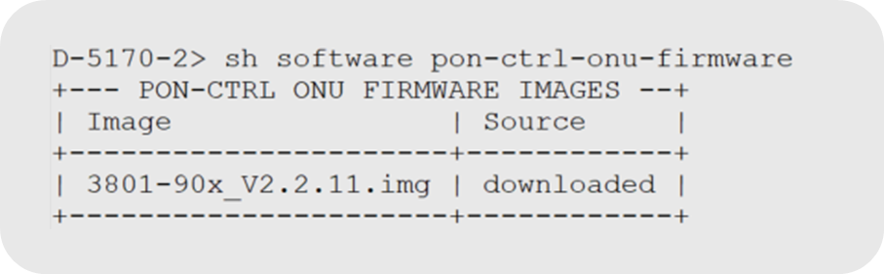

Note: The image file listed here is for a Ciena 3801 ONU and its version is compatible with SAOS 10.6.0It is **critical** that the **correct and supported version is used for the running SAOS 10 release**. Failure to load the correct ONU firmware version could cause the ONU to become unresponsive.

### How to transfer ONU firmware to the SAOS 10 device:

1. Transfer the correct ONU firmware to the SAOS 10 device acting as the PON controller:
2. D-5170-2> **software download sw-type pon-ctrl-onu-firmware url sftp://[username]:[password]@[ip address of SFTP server]/[network path/3801-90x_V2.2.11.img**
3. Verify the ONU firmware is available on the SAOS 10 device.

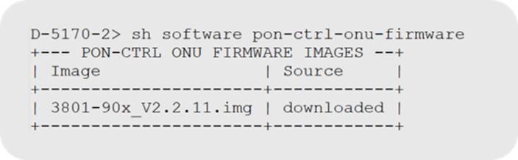

1. The PON controller will populate the “expected firmware” for the ONU. if the expected firmware version is the same as the active version running on the ONU, then operational state will go to registered. If not, the PON controller will attempt to update the firmware to the “expected” firmware version. The PON controller must have this file in its library in order to upgrade the firmware to the expected version.

Here we see an ONU that has been updated correctly. The active and expected firmware versions match.

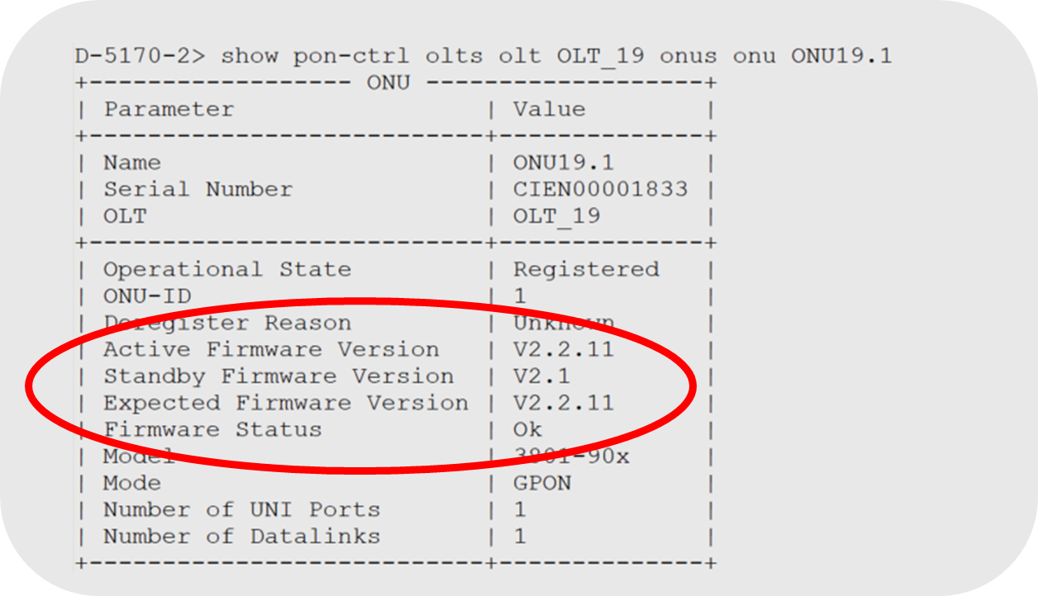

Consult Ciena Technical documentation for more details.

-End of Appendix